**“*National Instruments LabVIEW Install Reference Guide*”**

# **TABLE OF CONTENTS**

**II.** **TABLE OF CONTENTS** 2

**III.** **REVISION LOG** 4

**IV.** **PROCEDURE STATUS** 4

**V.** **REFERENCES** 4

**VI.** **PURPOSE** 4

**VII.** **SCOPE** 4

**VIII.** **PERSONNEL TRAINING AND QUALIFICATION** 4

**IX.** **APPARATUS AND EQUIPMENT** 4

**X.** **PROCEDURE** 6

**A.** **NI Developer Suite 2015 DS2 Install** 6

**B.** **Software Activation 2015 Developer Suite** 37

**C.** **LabVIEW 2015 SP1** 43

**D.** **Software Activation 2015 SP1** 55

**E.** **NI Update Service Post LabVIEW 2015 SP1 Installation** 60

**F.** **NI-Industrial Communications for EtherCAT 15.0.0** 77

**G.** **LabVIEW 2019** 87

H. **NI Compact RIO 18.1** 104

**I.** **NI-Industrial Communications for EtherCAT 18.0.0** 112

**J.** **NI Update Post NI-Industrial Communications for EtherCAT 18.0.0 Install** 122

**K.** **NI-CAN** 129

**L.** **JKI Package Manager** 138

**M.** **Open GDS** 144

**N.** **VIPM Installs** 152

**A.** **OpenG** 152

**B.** **MGI** 162

**C.** **Misc VIPM Packages** 177

**D.** **Downgrading Installed Packages** 181

**E.** **VIPM Installed Packages** 189

**O.** **MAX Software Summary** 191

# **REVISION LOG**

|  |  |  |  |  |
| --- | --- | --- | --- | --- |
| **Revision: 1.0** | | **Effective Date:** | | |
| **Section** | **Justification** | | | **Changes** |
|  |  | | |  |
| **Impact of above change(s) on other documents:** | | |  | |

# **PROCEDURE STATUS**

The status of this procedure is: **DRAFT.**

# **REFERENCES**

1. <https://www.ni.com/en.html>
2. [https://www.ni.com/en/support/downloads/software-products/download.labview.html#521715](https://www.ni.com/en/support/downloads/software-products/download.labview.html%23521715 )
3. \\c1315mv65\groups\Private\TestSupport\JADEC Commissioning\Software\National Instruments
4. <https://www.ni.com/pdf/manuals/374715c.html>

# **PURPOSE**

This quick start guide provides instructions on how to install National Instruments LabVIEW in preparation for working with JCI Software Projects.

# **SCOPE**

This procedure applies to all personnel who will be using National Instruments Software Products at JCI.

# **PERSONNEL TRAINING AND QUALIFICATION**

1. System Users need to have proficiency with:
   1. Microsoft Windows
   2. National Instruments Software
2. Access to “Y” Drive

# **APPARATUS AND EQUIPMENT**

Minimum System Requirements for National Instruments LabVIEW.

|  |  |  |
| --- | --- | --- |
| **Windows** | **Run-Time Engine** | **Development Environment** |
| Processor | Pentium III/Celeron 866 MHz (or equivalent) or later (32-bit) Pentium 4 G1 (or equivalent) or later (64-bit) | Pentium 4M (or equivalent) or later (32-bit) Pentium 4 G1 (or equivalent) or later (64-bit) |
| RAM | 256 MB | 1 GB |
| Screen Resolution | 1024 x 768 pixels | 1024 x 768 pixels |
| Operating System | Windows 8.1/8/7/Vista (32-bit and 64-bit) Windows XP SP3 (32-bit) Windows Server 2012 R2 (64-bit) Windows Server 2008 R2 (64-bit) Windows Server 2003 R2 (32-bit) | Windows 8.1/8/7/Vista (32-bit and 64-bit) Windows XP SP3 (32-bit) Windows Server 2012 R2 (64-bit) Windows Server 2008 R2 (64-bit) Windows Server 2003 R2 (32-bit) |
| Disk Space | 620 MB | 5 GB (includes default drivers from the NI Device Drivers media) |
| Color Palette | N/A | LabVIEW and the *LabVIEW Help* contain 16-bit color graphics. LabVIEW requires a minimum color palette setting of 16-bit color. |
| Temporary Files Directory | N/A | LabVIEW uses a directory for storing temporary files. National Instruments recommends that you have several megabytes of disk space available for this temporary directory. |
| Adobe Reader | N/A | You must have Adobe Reader installed to search PDF versions of all LabVIEW manuals. |

# **PROCEDURE**

## **NI Developer Suite 2015 DS2 Install**

1. Navigate to \\c1315mv65\groups\Private\TestSupport\JADEC Commissioning\Software\National Instruments.
2. Open the Folder “LabVIEW 2015”
3. Open the Folder " 501400AP-01M_2015DS2DVD1_ENG”
4. 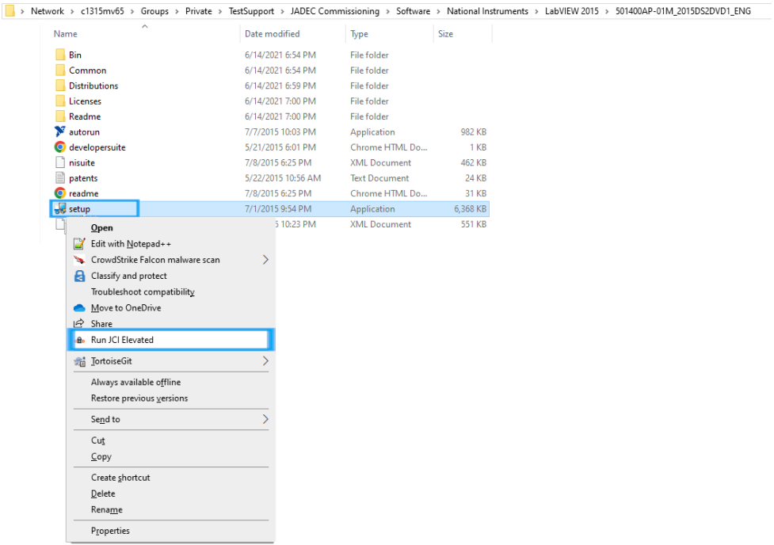Run Setup.exe (Application) by right clicking and selecting
5. 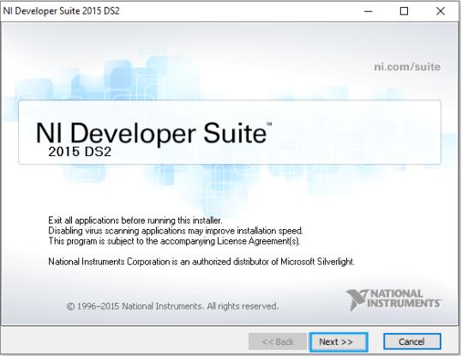 A “NI Developer Suite 2015 DS2” Window will open. This window will direct the user thru the installation process. Press “Next” to proceed.
6. 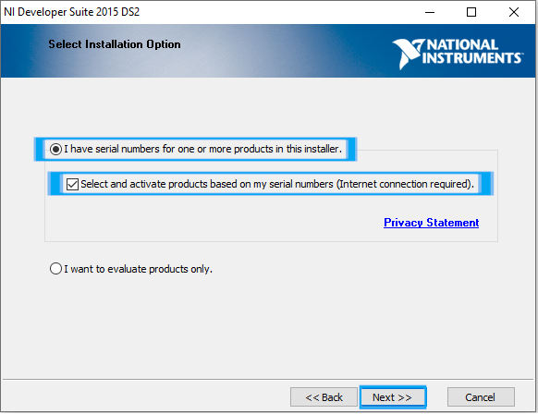The next setup screen will display. This screen prompts the user to “Select Installation Option”. That option is whether to use a serial number or to just evaluate the product.
7. Verify that “I have serial numbers for one or more products in this installer.” Is selected.
8. Verify “Select and activate products based on my serial numbers.” is selected.
9. Press “Next” to proceed.
10. The next Screen will prompt the user to enter serial number(s).
    1. 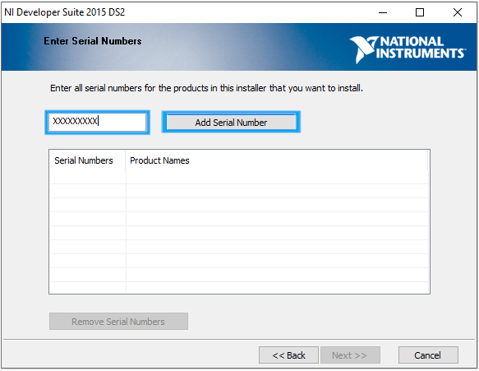For each serial number:
       1. Enter the serial number in the provided text box.
       2. Press “Add Serial Number”
       3. 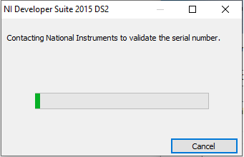Another “NI Developer Suite 2015 DS2” Window will display to validate the serial number.
       4. A serial number for “LabVIEW Professional” and “LabVIEW Real-Time Module” will be entered.
       5. 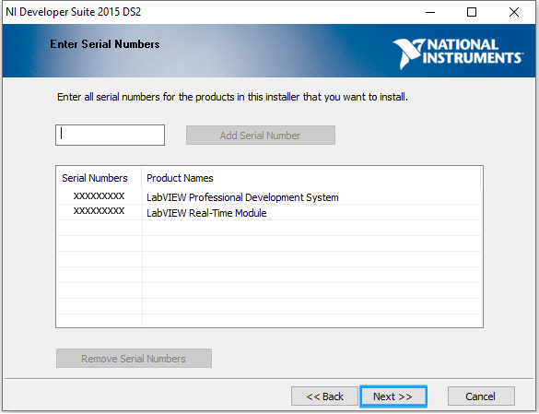When both serial numbers are validated. Press “Next” to proceed.
11. The next screen will prompt the user to select the “Product(s)” from the “Licensed Product List”
    1. 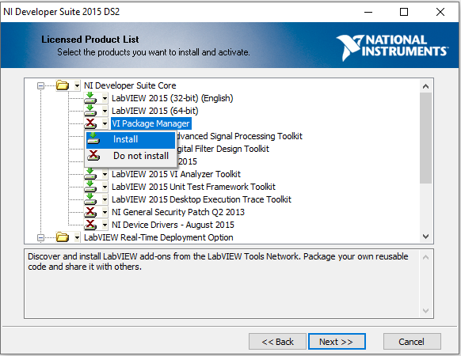Click the drop down on “VI Package Manager” and select the option Install.
    2. 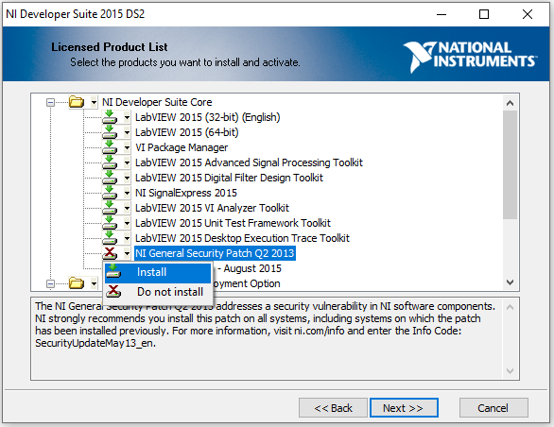Click the drop down on “NI General Security Patch Q2 2013” and select the option Install.
    3. 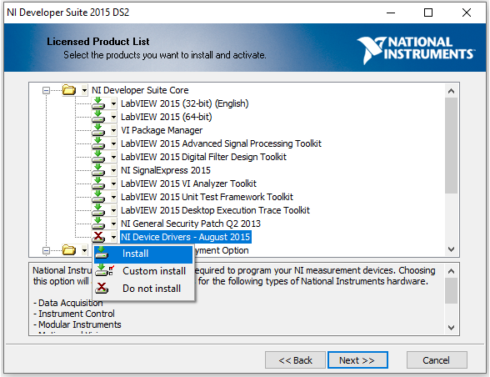 Click the drop down on “NI Device Drivers – August ” and select the option Install.
    4. 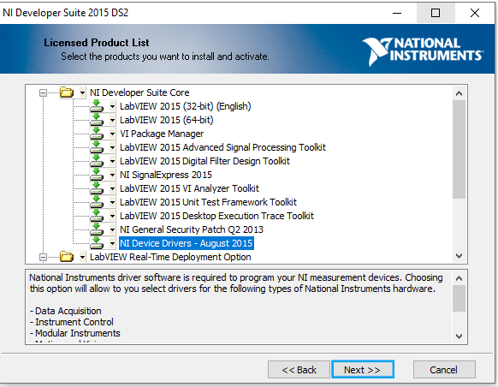Press “Next” to proceed.
12. 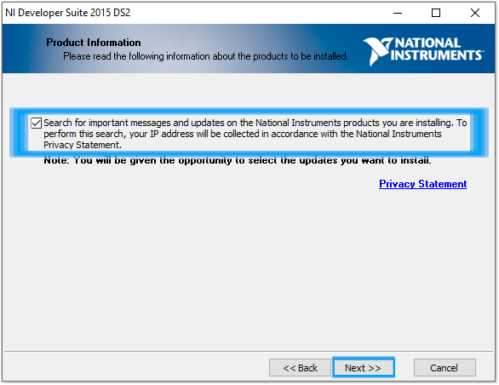The next screen is prompting the user to determine if they want to check for important updates to the products they are choosing to install. Please verify that the box is checked and press “Next” to proceed.
13. 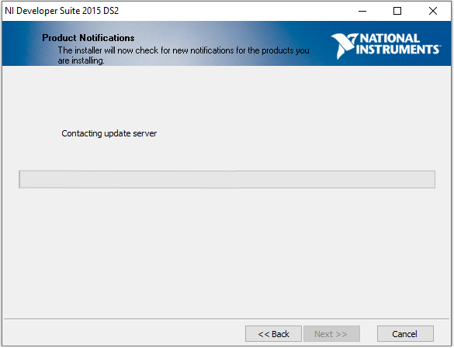The next screen will proceed to check for any important updates to the selected products. When it is done, it will go away and proceed to the next screen.
14. 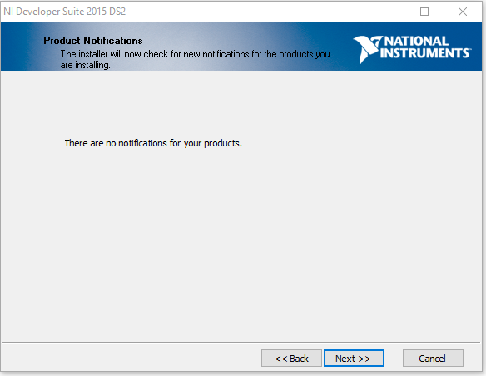The next screen will go over any important updates for the selected products. There should be no updates.

Press “Next” to proceed.

1. 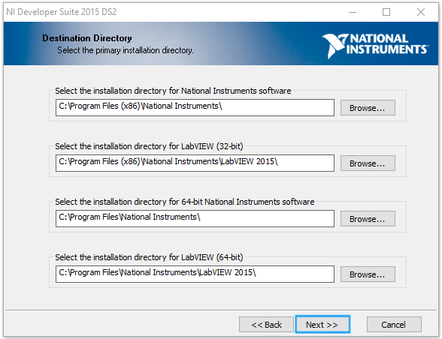The next screen will provide a list of directories for install files. Press “Next” to proceed.
2. 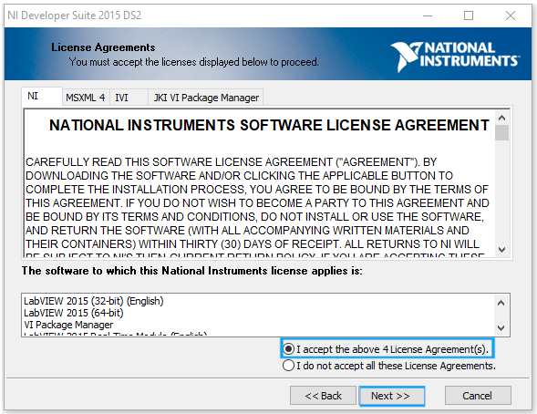The next screen will ask the user to accept the license agreements. Please select “I accept the above x License Agreement(s).” and press “Next” to proceed.
3. 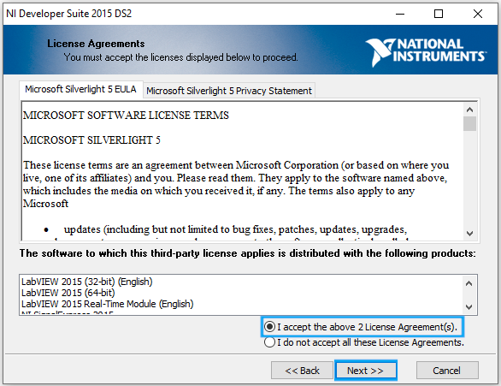The next screen is more license agreement acceptance. Please select “I accept the above x License Agreement(s).” Press “Next” to proceed.
4. 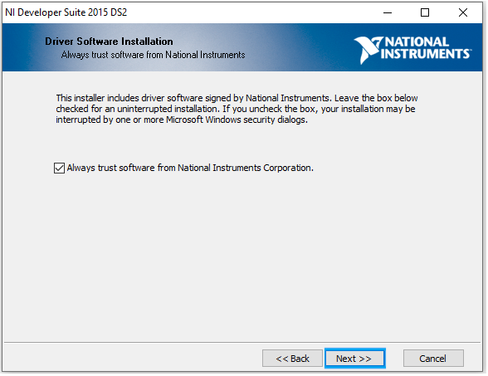The next screen is prompting the user to always trust software from National Instruments Corporation. Verify “Always trust software from National Instruments Corporation.” is selected. Press “Next” to proceed.
5. 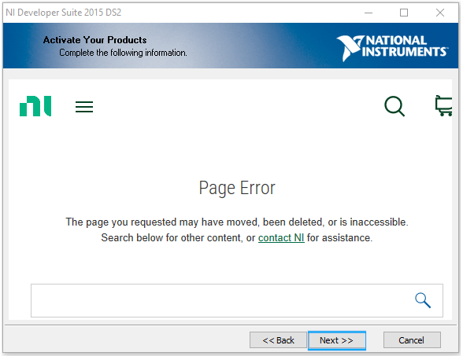The next screen will try to active the products. It may show a “Page Error” or need to be refreshed. This is due to the software being older and web pages changing. Press “Next” to proceed.
6. 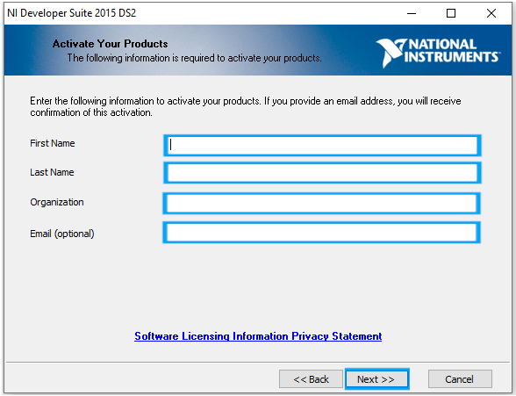The next screen will prompt for user information. Please fill in “First Name”, “Last Name”, “Organization”, and “Email”. Press “Next” to proceed.
7. 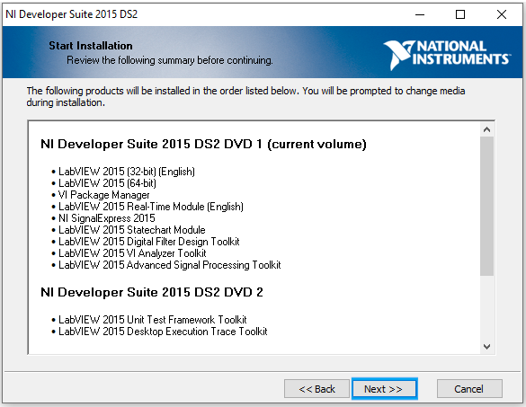The next step will verify the products to be installed and once “Next” is pressed, installation will begin. Press “Next” to proceed.
8. 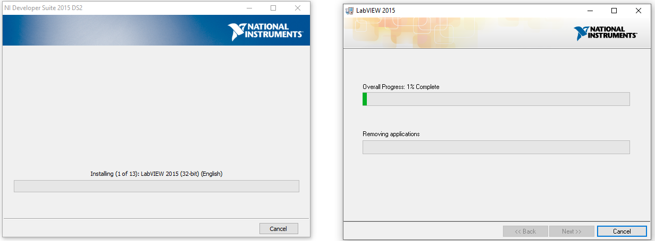Installation will now begin. Please wait for it to finish before proceeding. The screen may flash and/or command prompts may appear. This is normal.
9. During Installation, the user will be prompt to enter the location for Disc 2, Disc 3, and Instrument Drivers. There can be found on the “Y” Drive at:
   1. 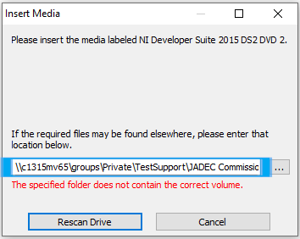 Disc 2 – “Groups\Private\TestSupport\JADEC Commissioning\Software\National Instruments\LabVIEW 2015\501400AP-02M_2015DS2DVD2”
   2. 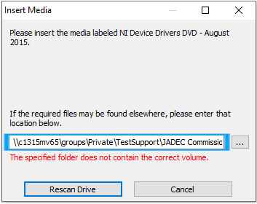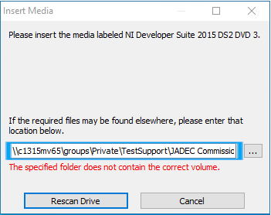Disc 3 – “Groups\Private\TestSupport\JADEC Commissioning\Software\National Instruments\LabVIEW 2015\ 501400AP-03M_2015DS2DVD3”
   3. Instrument Drivers – “Groups\Private\TestSupport\JADEC Commissioning\Software\National Instruments\NI Device Drivers\Aug15\DCD-Aug15-1”
10. 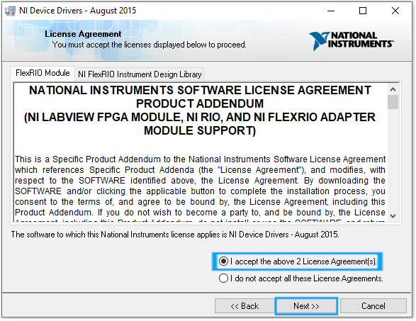For the Instrument Drivers, the user is prompted to accept x License Agreements. At this screen, please select “I accept the above x License Agreement(s).” Press “Next” to proceed.
11. Installation will continue.
12. 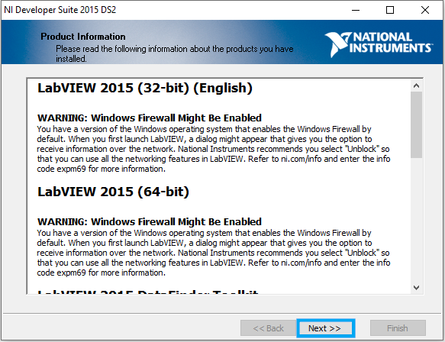Once installation is complete, a “Product Information” screen will display. This screen displays information about the products that were installed. Press “Next” to proceed.
13. 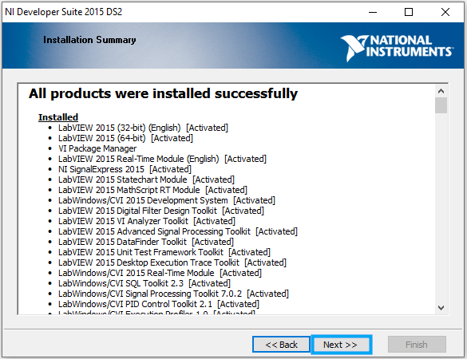The next screen is the “Installation Summary”. This screen shows all of the products that were installed. Press “Next” to proceed.
14. 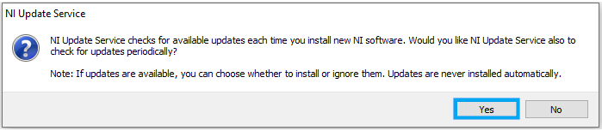After the previous screen is advanced, a “NI Update Service” window displays. Select “Yes” to prompt the software to check for updates.
15. 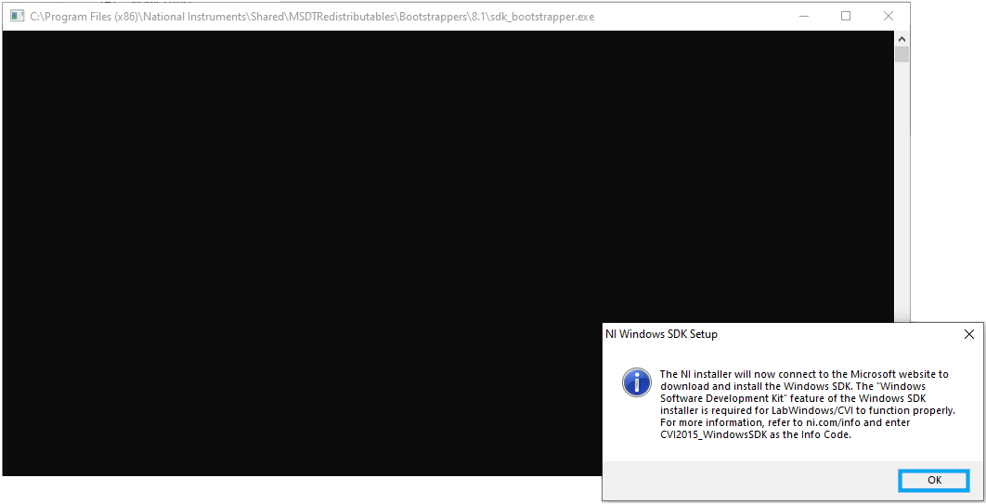Another prompt will now appear, alerting the user that the installer will now connect to a website to install “Windows Software Development Kit”. Press “Yes” to proceed.
16. 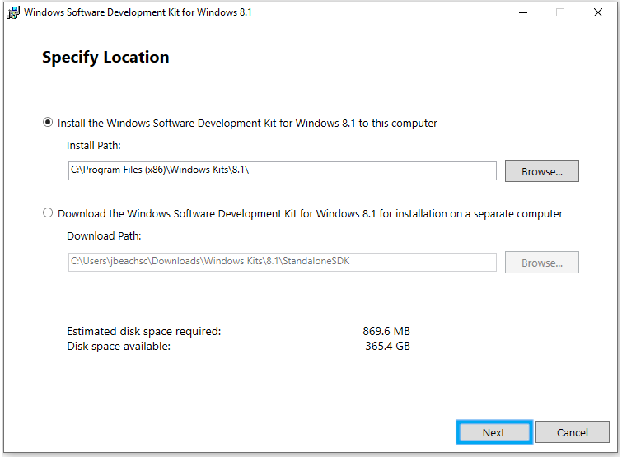A “Windows Software Development Kit for Windows 8.1” window will now display. Keep all settings default and press “Next” to proceed.
17. 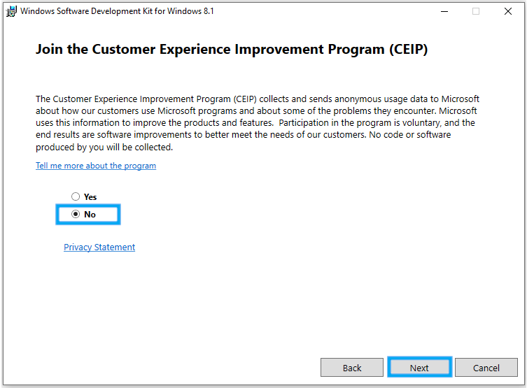The next screen will ask the user to “Join the Customer Experience”. Verify “No” is Selected and then press “Next” to proceed.
18. 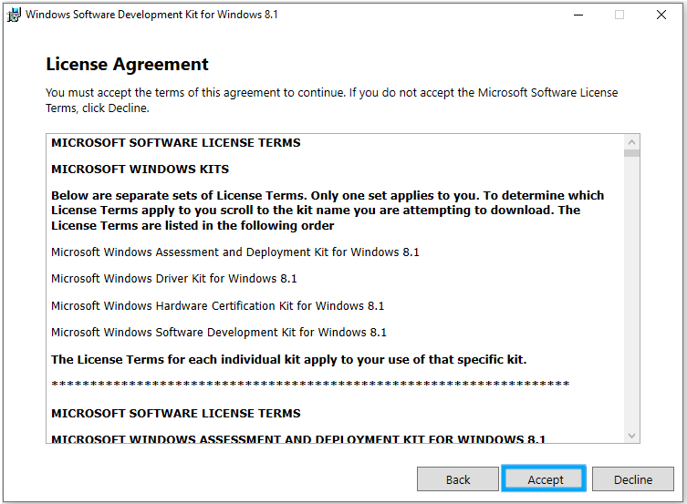The next screen is a “License Agreement” screen. Press “Accept” to proceed.
19. 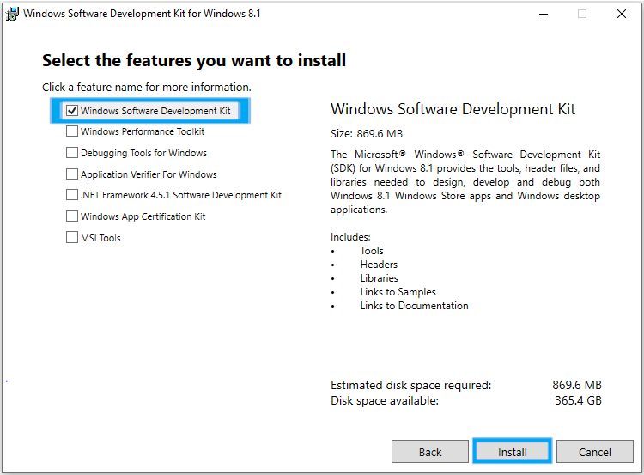The next screen will prompt the user to “Select the features you want to install”. Verify “Windows Software Development Kit” is selected and press “Install” to start installing.
20. 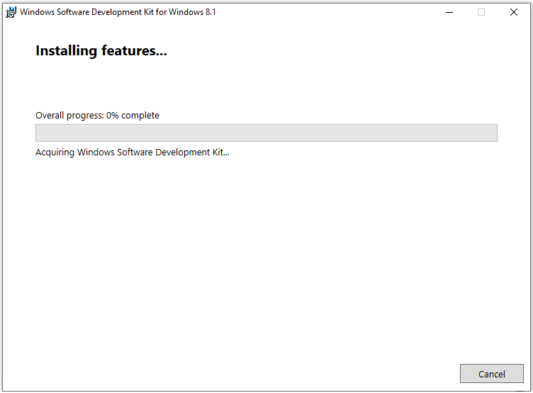The software will begin to install. Please, wait for the installation to complete.
21. 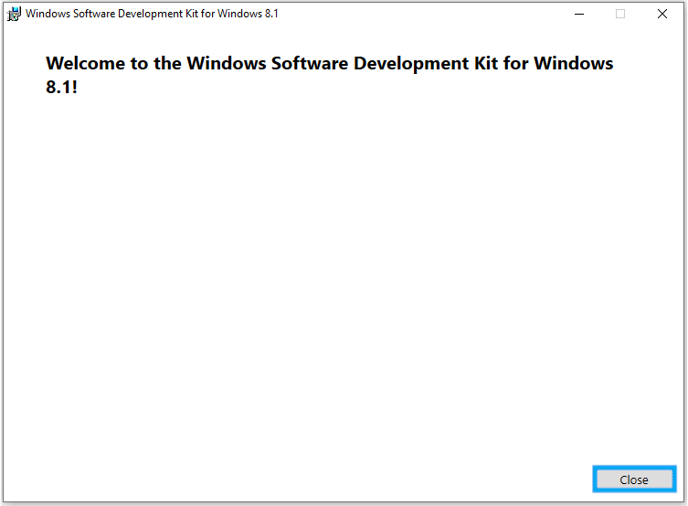After installation if complete, a “Welcome” screen will appear. Press “Close” to close the window.
22. 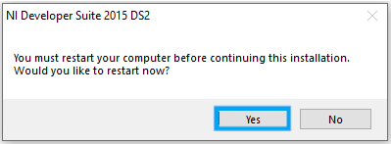An “NI Developer Suite 2015 DS2” window will appear. This prompt will ask the user to restart the PC to complete installation. Press “Yes” to proceed.
23. The PC will now restart.
24. 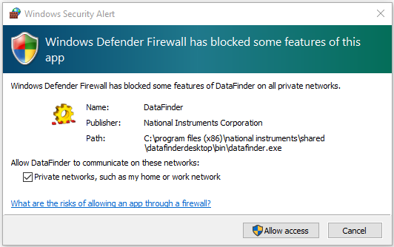After Windows reboots, there will e a “Windows Firewall” Prompt. Press “Allow Access” to proceed.
25. 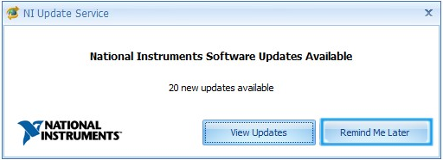A “NI Update Service” Window will come up after this. Press “Remind Me Later”

## **Software Activation 2015 Developer Suite**

1. 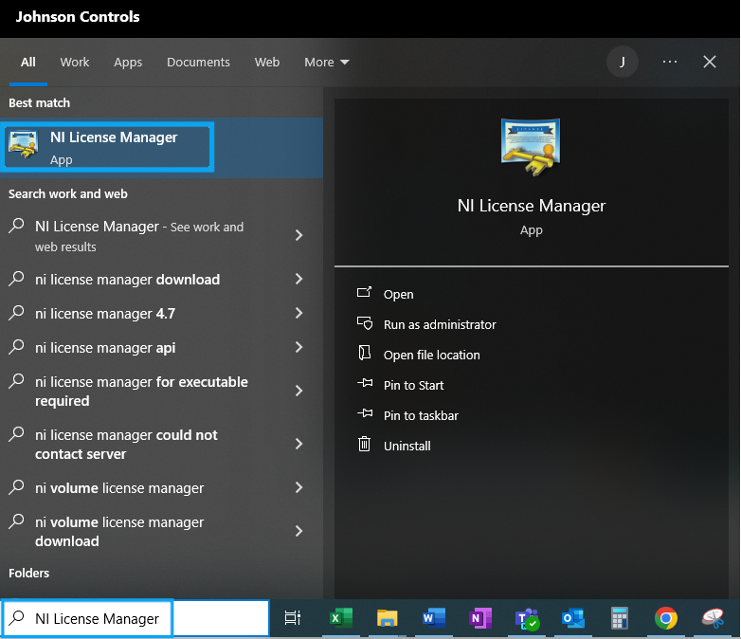From the start menu search, type “NI License Manager”. Then select "NI License Manager”.
2. 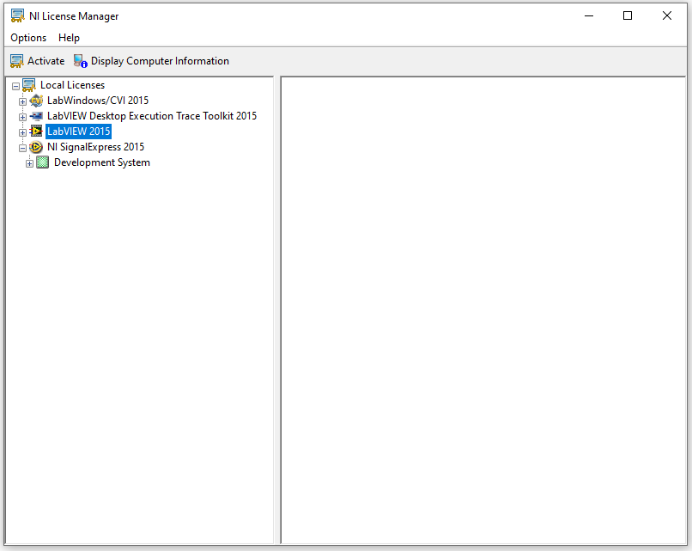NI License Manager will then open.
3. 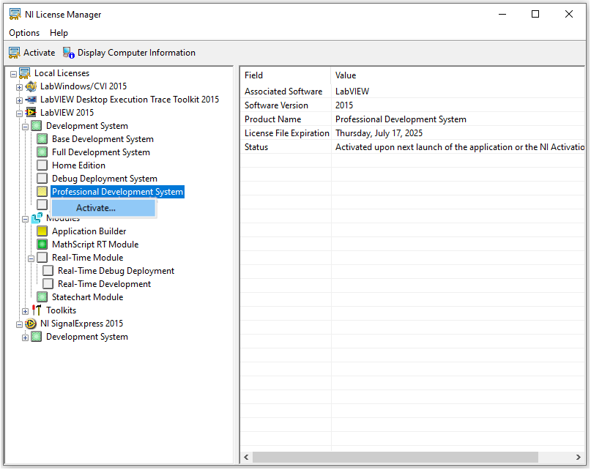Expand “LabVIEW 2015”. Right click on “Professional Development System” and select “Activate”.
4. 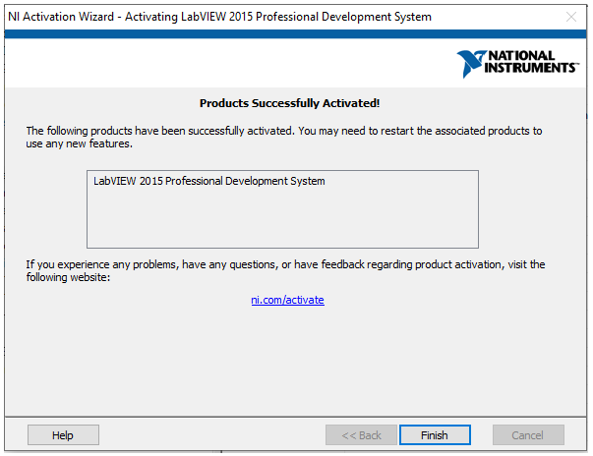Follow instructions, entering the serial number, when prompted, until successful activation of “Professional Development System”.
5. 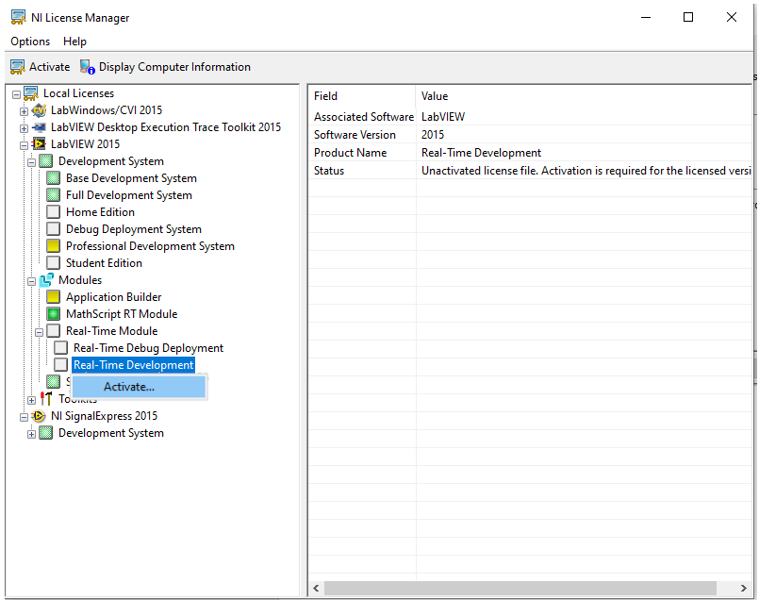\Expand “Modules” and then expand “Real-Time Module”. Right click on “Real Time Development” and select “Activate”.
6. 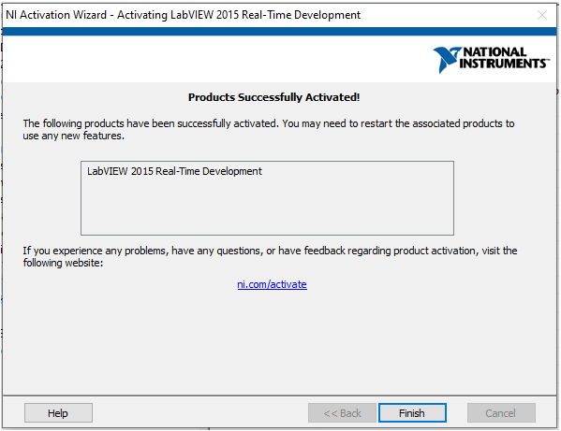Follow instructions, entering the serial number, when prompted, until successful activation of “Real-Time Module”.
7. Close “Ni License Manage”.

## **LabVIEW 2015 SP1**

1. Navigate to \\c1315mv65\groups\Private\TestSupport\JADEC Commissioning\Software\National Instruments.
2. Open the Folder “2015sp1LV-WinEng”
3. 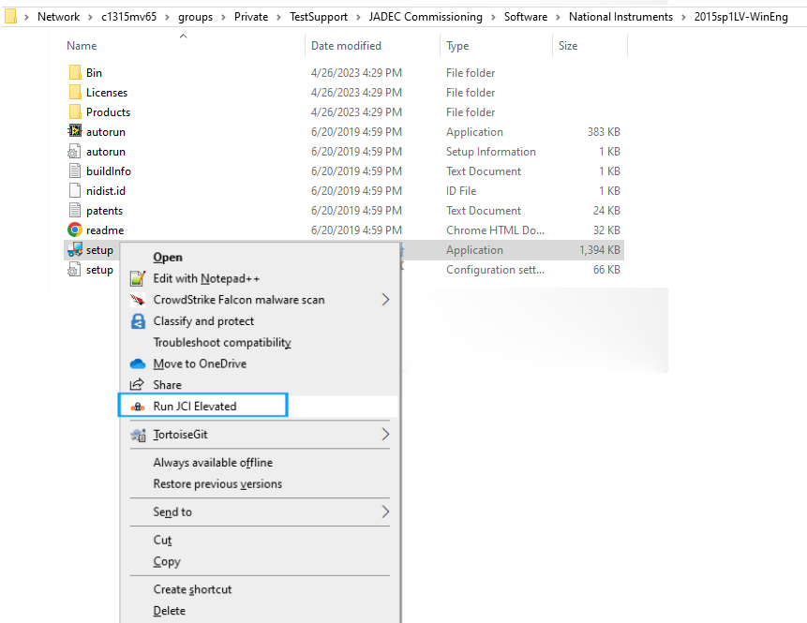Right click on “Setup” and select “Run JCI Elevated”
4. 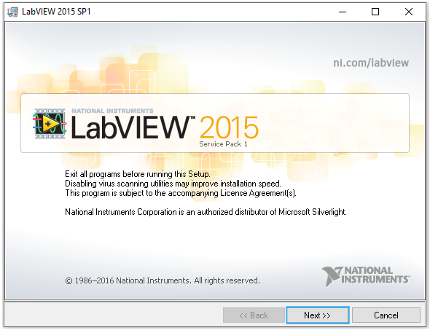A screen will display to start the Installation. Press “Next” to proceed.
5. 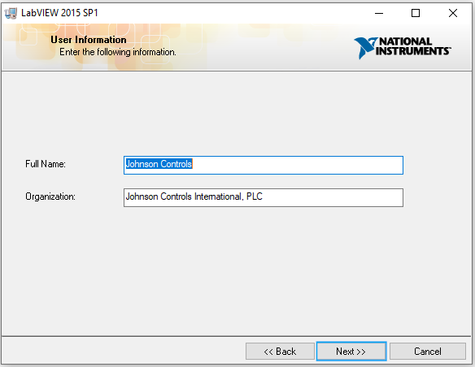This screen will display the user information. It should be populated. If it is not, populate it as shown. Press “Next” to proceed.
6. 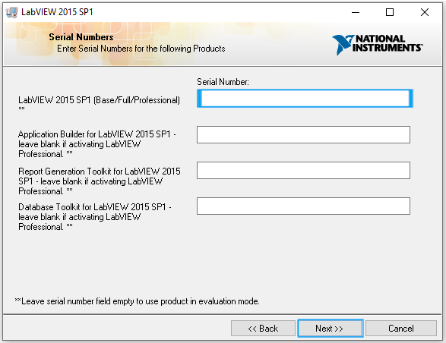Enter at last the serial number for “LabVIEW 2015 SP1”. Press “Next” to continue.
7. 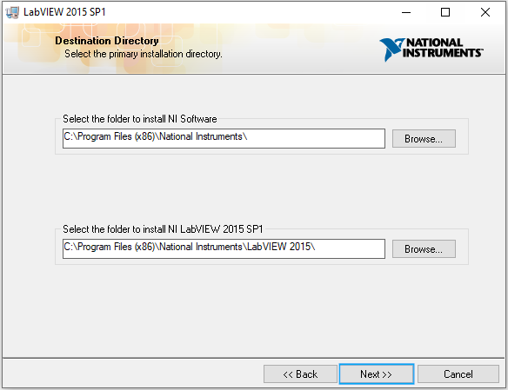This screen will ask for the destination directory. Leave them default. Press “Next” to proceed.
8. 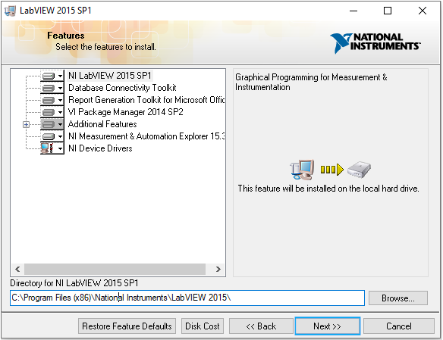This screen will ask the user to confirm the features to be installed. Leave all default. Press “Next” to proceed.
9. 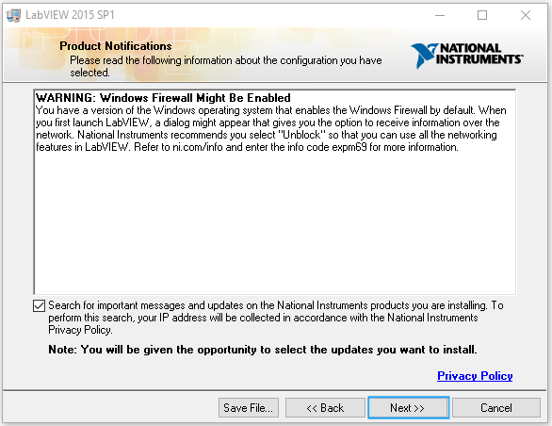This screen will prompt the user about “Product Notifications”. Verify that “Search for important updates” is checked and press “Next” to proceed.
10. 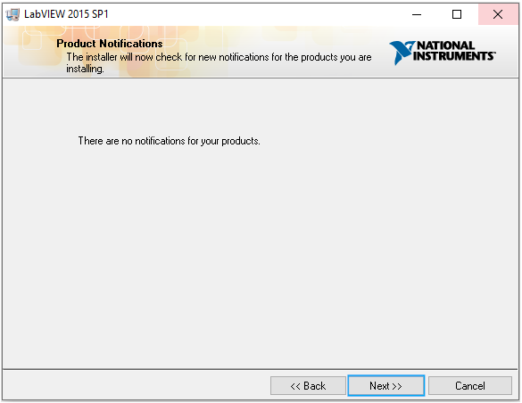The next screen will search for important product updates. There should not be any but, if there are, install them. Press “Next” to proceed.
11. 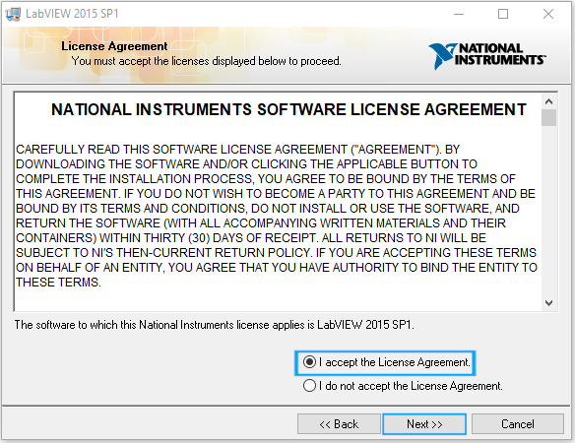The next screen will prompt the user to accept x “License Agreements”. Select “I accept the License Agreement” and press “Next” to proceed.
12. 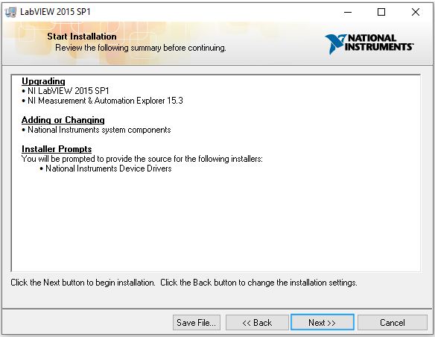This next screen will confirm what is being installed and by clicking “Next”, installation will begin. Press “Next” to proceed.
13. 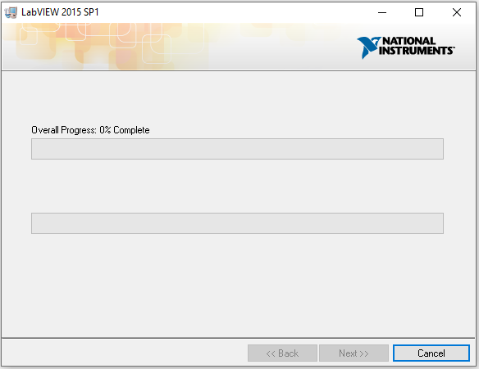Installation will begin. The next screen will go thru progress and install the software. Please, wait for it to complete.
14. 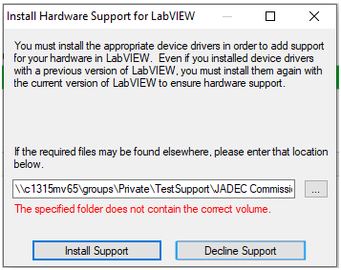An Option for installing support will come up towards the end of installation. Press “Decline Support” to proceed.
15. 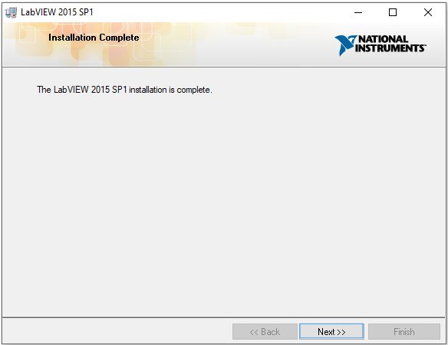When installation is complete, the next screen will display, notifying that installation is complete. Press “Next” to continue.

## **Software Activation 2015 SP1**

1. 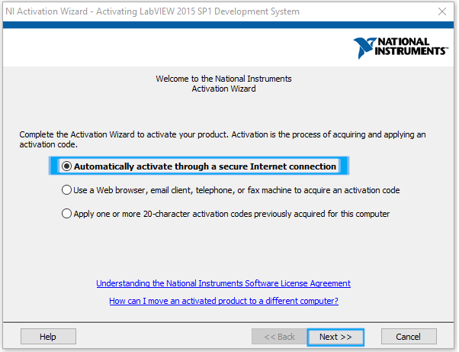 After LabVIEW 2015 SP1 Installation, a prompt to activate the software will come up. Verify “Automatically activate though a secure Internet connection” is selected and press “Next” to proceed.
2. 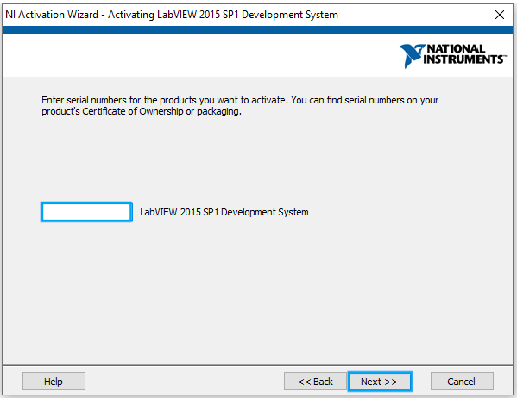The next screen will prompt the user for their serial number for activation. Verify or enter the correct serial number and press “Next” to proceed.
3. 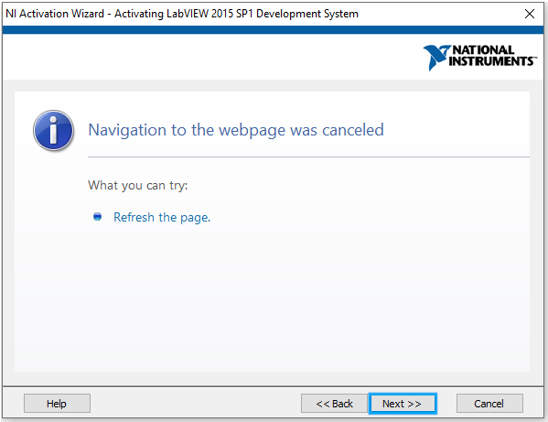The next screen will try to active the products. It may show a “Page Error” or need to be refreshed. This is due to the software being older and web pages changing. Press “Next” to proceed.
4. 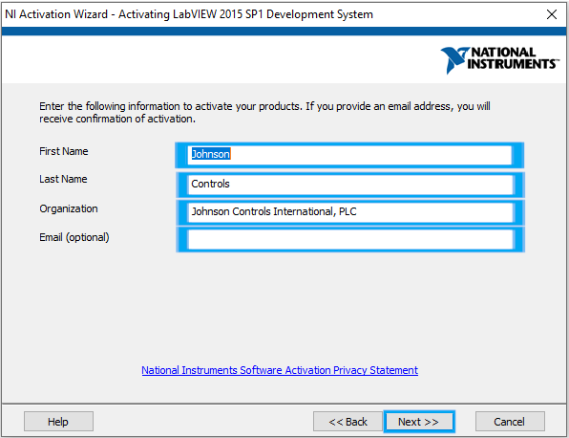The next screen will prompt for the user information. Verify or enter the information displayed and press “Next” to proceed.
5. 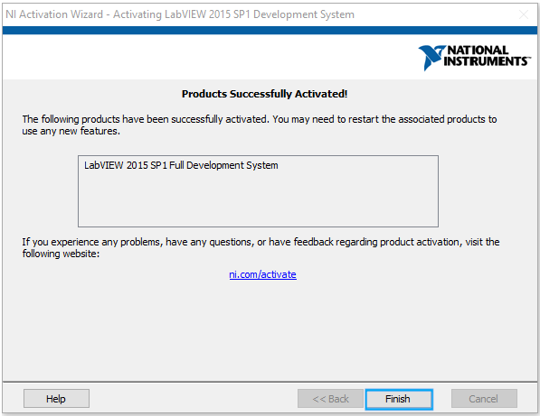The application will then activate the product(s). Upon completion, a multiple “Products Successfully Activated!” screens will display. Press “Finish” to proceed with each one.
6. 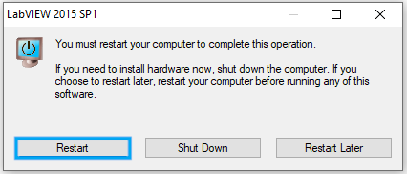A final screen will display asking the user to “restart the computer to complete this operation”. Press “Restart” to proceed.

## **NI Update Service Post LabVIEW 2015 SP1 Installation**

1. 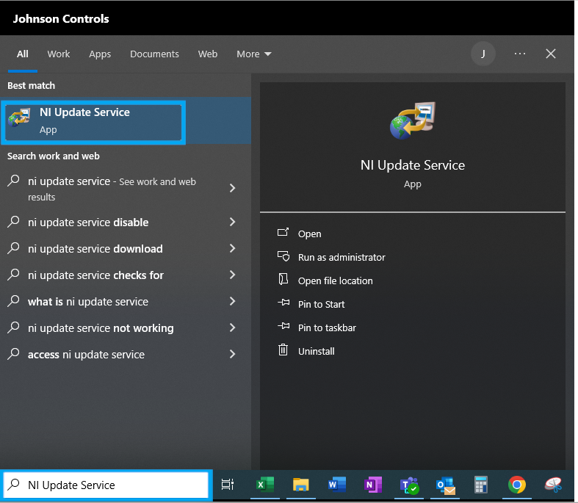On Windows Start Search type “NI Update Service” and select “NI Update Service”.
2. 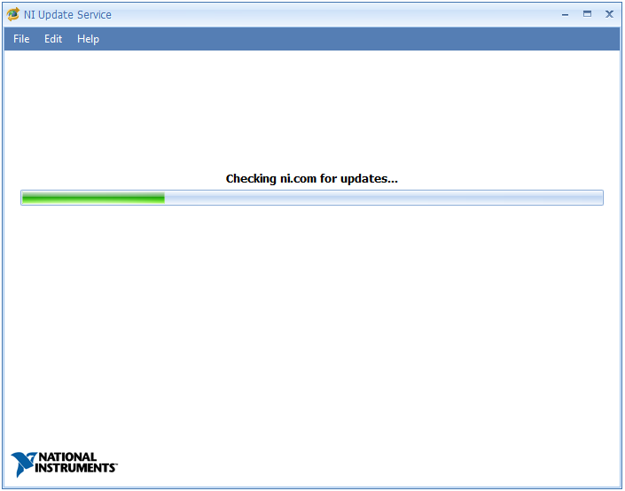The window will then search NI.com for Updates.
3. 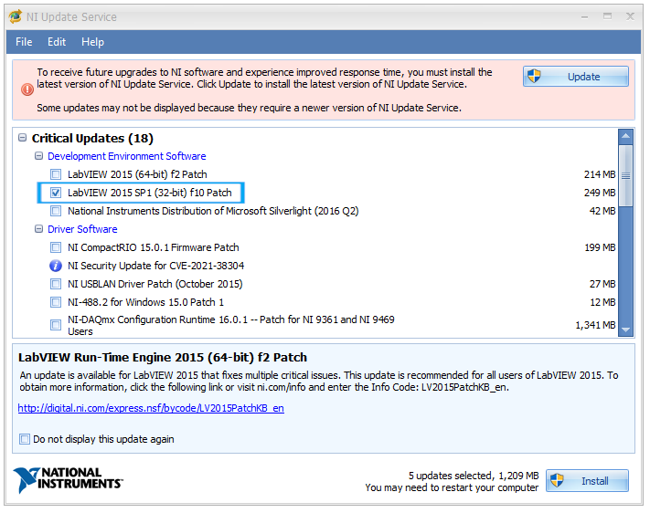Select “LabVIEW 2015 SP1 (32-bit) f10 Patch”
4. 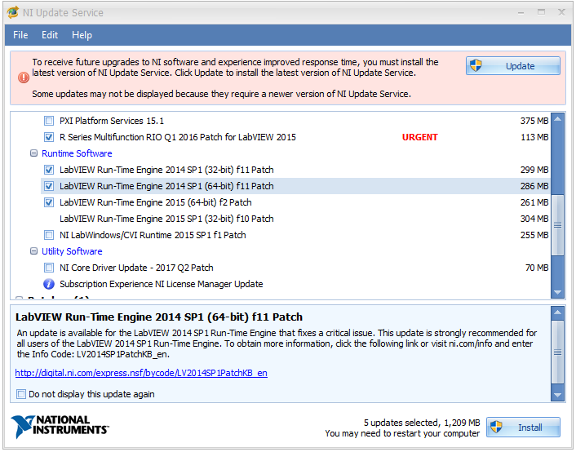Select “R Series Multifunction RIO Q1 2016 Patch for LabVIEW 2015”, LabVIEW Run-Time Engine 2014 SP1 (32-bit) f11 Patch”, LabVIEW Run-Time Engine 2014 SP1 (64-bit) f11 Patch”, and “LabVIEW Run-Time Engine 2015 SP1 (64-bit) f2 Patch LabVIEW Run-Time Engine 2015 SP1 (32-bit) f10 Patch”
5. 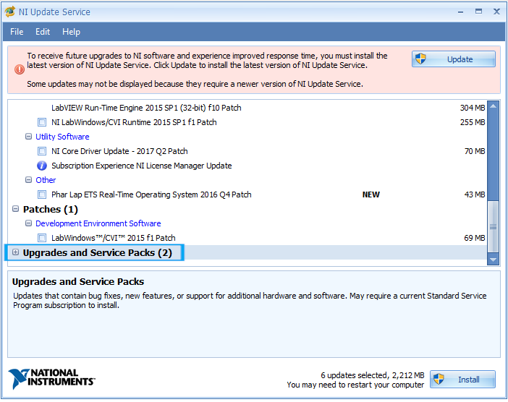Expand “Upgrades and Service Packs (2)” The window will now check NI.com.

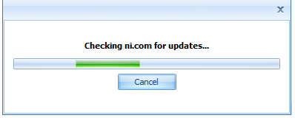

1. 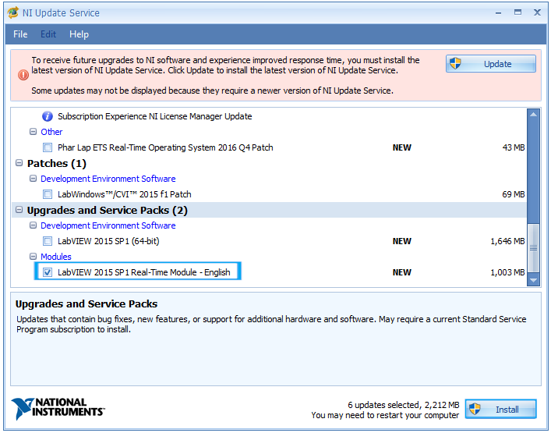Select “LabVIEW 2015 SP1 Real-Time Module – English”. Press “Install” to start installing updates.
2. 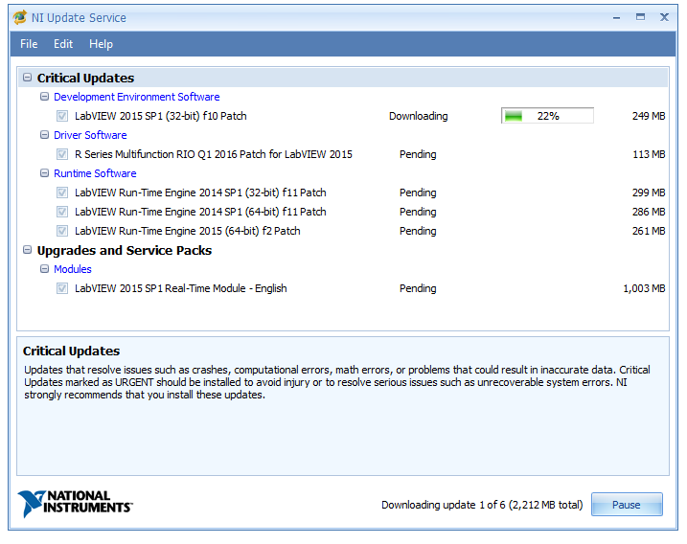“NI Update Services” will then download and install the selected updates. Please wait for it to finish.
3. 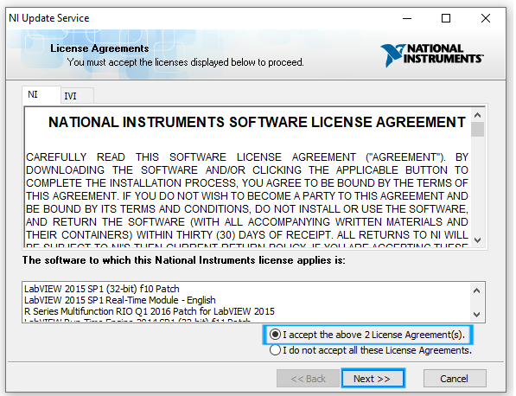The next screen will ask to accept License agreements. Select “I accept the above 2 License Agreements(s)” and press “Next” to proceed.
4. 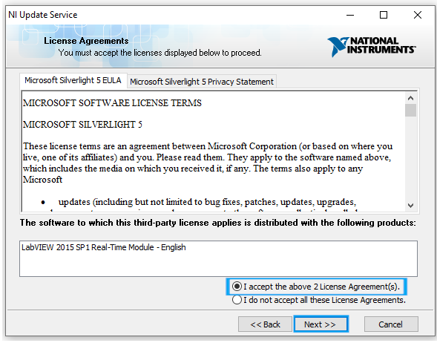The next screen will ask to accept more License agreements. Select “I accept the above 2 License Agreements(s)” and press “Next” to proceed.
5. 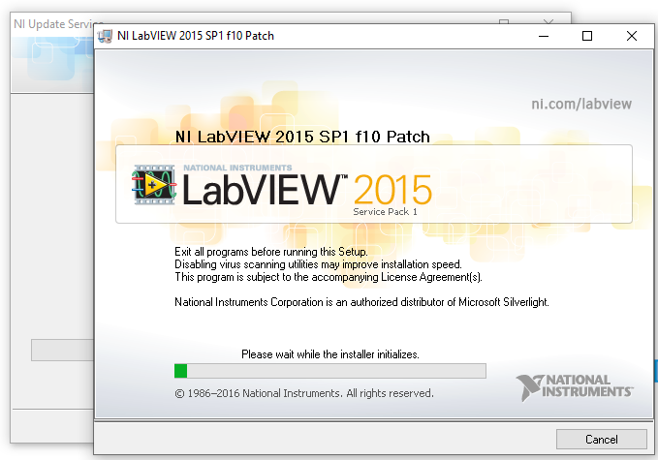The installer will now begin to install the updates. Please, wait until the updates are complete.
6. 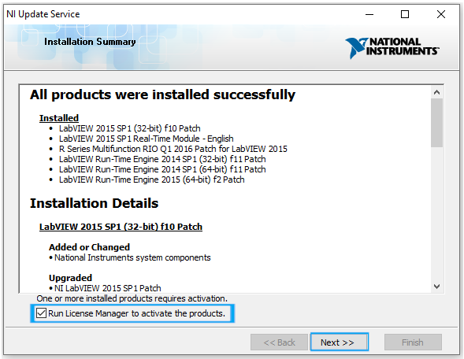After installation, a screen will show the installation summary. Please check “Run License Manager to active the products” and press “Next” to proceed.
7. 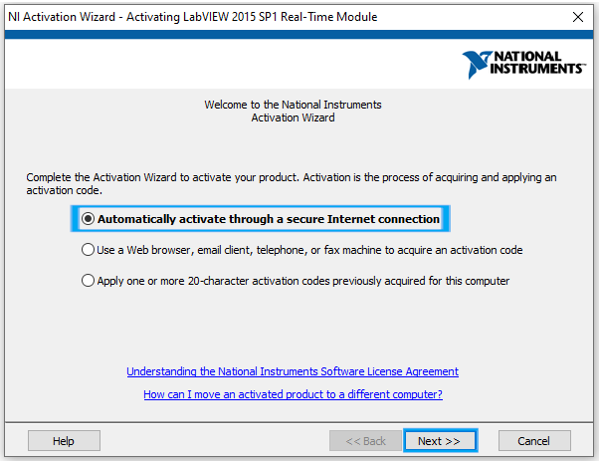The “NI Activation Wizard” will now run. Verify “Automatically activate through a secure internet connection” and press “Next” to proceed.
8. 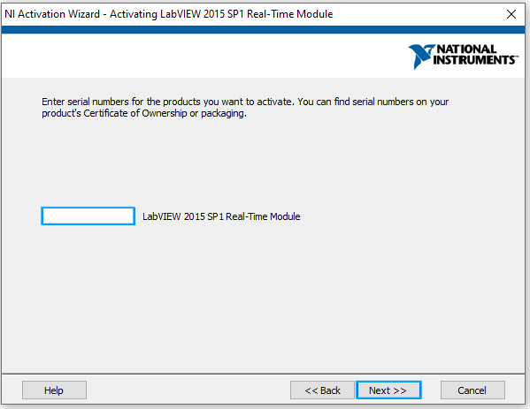The next screen will ask for the serial number to activate the product(s). Verify or enter the serial number and press “Next” to proceed.
9. 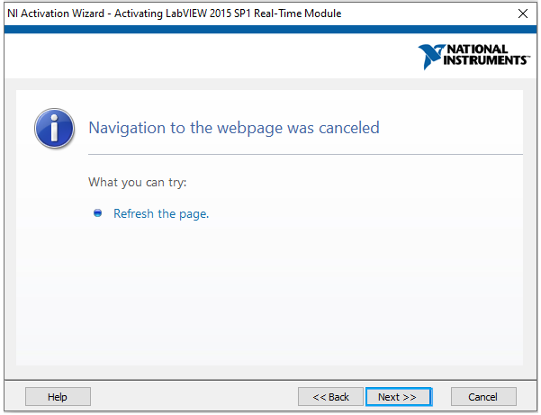The next screen will try to active the products. It may show a “Page Error” or need to be refreshed. This is due to the software being older and web pages changing. Press “Next” to proceed.
10. 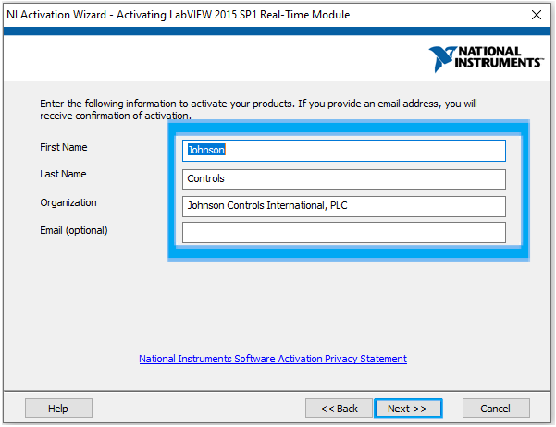The next screen will prompt for user information. Verify or enter the information and press “Next’ to proceed.
11. 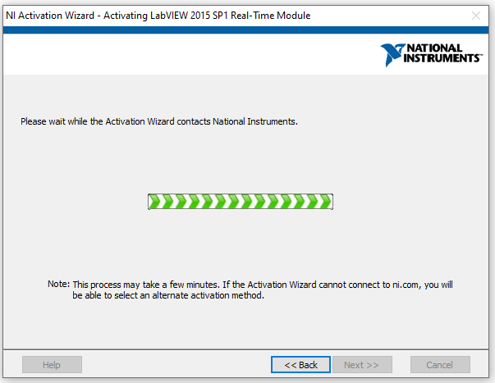He “Activation Wizard” will now attempt to activate the license. Please, wait for it to finish.
12. 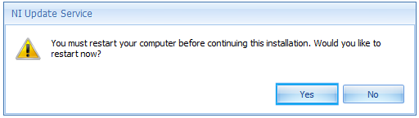Now the user will be prompt to “restart your computer before continuing”. Press “Yes” to proceed.
13. 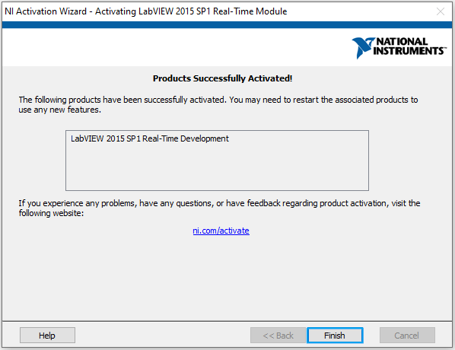The next screen should show “Products Successfully Activated”. Press “Finish” to proceed.

## **NI-Industrial Communications for EtherCAT 15.0.0**

1. Navigate to \\c1315mv65\groups\Private\TestSupport\JADEC Commissioning\Software\National Instruments.
2. Open the Folder “NI-Industrial Communications for EtherCAT”
3. Open the Folder " 15.0.0”
4. 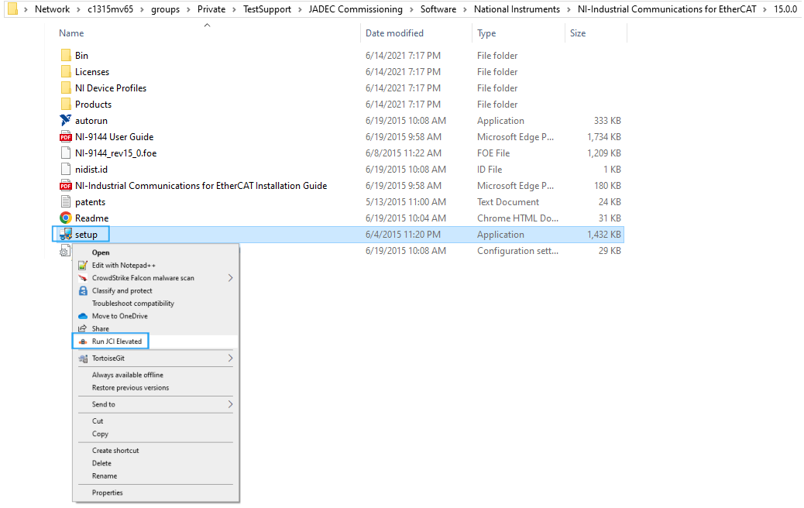Right click on “Setup” and select “Run JCI Elevated”
5. 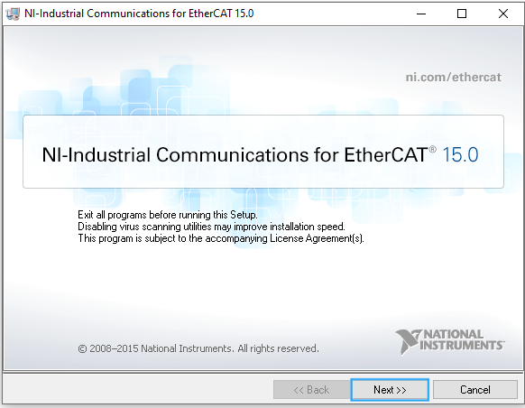A “NI-Industrial Communications for EtherCAT 15.0” Window will come up. Press “Next” to proceed.
6. 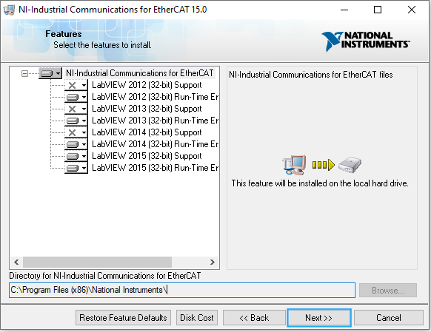The next screen will prompt the user to select the features to install. Keep everything default and press “Next” to continue.
7. 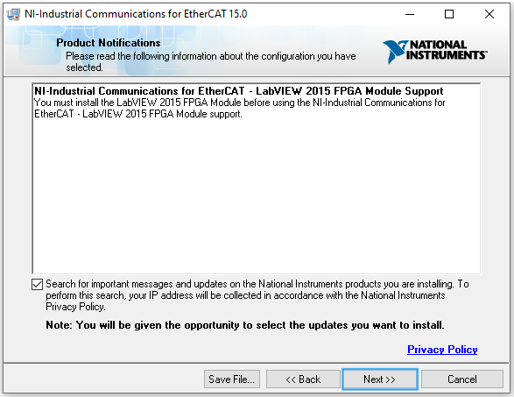The next screen will prompt the user to see if they want to check for important updates. Verify “Search for important updates” is selected and press “Next” to proceed.
8. 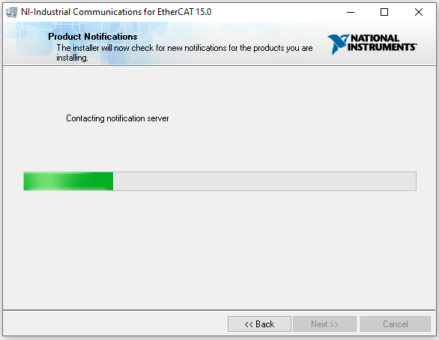The installer will then check for updates.
9. 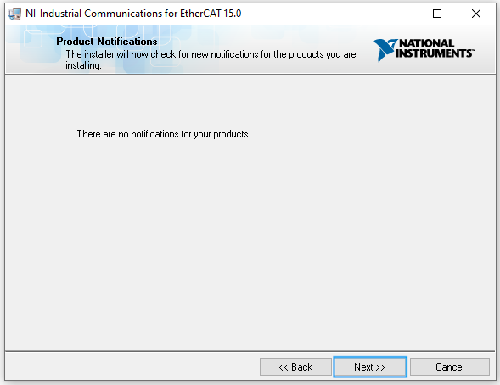The next screen will review the updates. There should not be any. Press “Next” to proceed.
10. 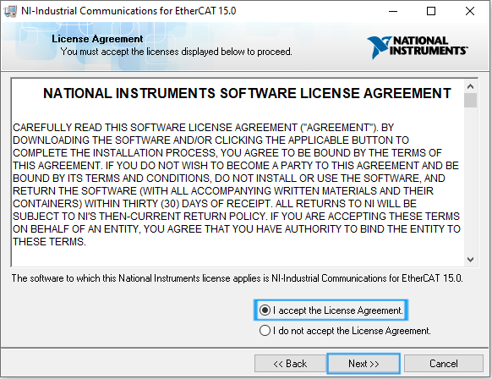The next screen is license agreements. Check “I accept the License Agreement” and press “Next” to proceed.
11. 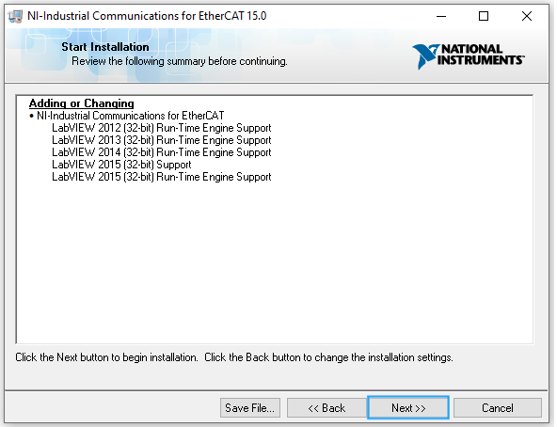The next screen will prompt to start the installation. Press “Next” to proceed.
12. 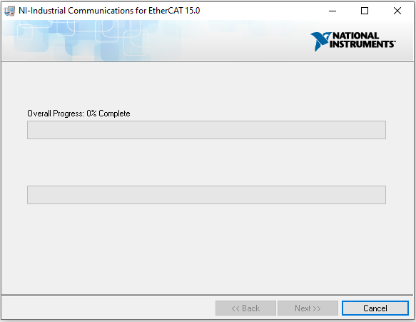Installation will now being. Please, wait for installation to complete.
13. 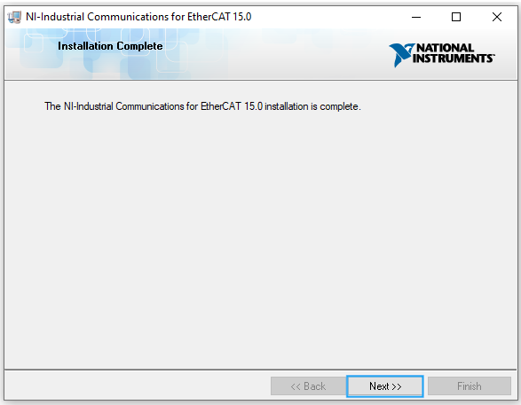An installation complete screen will come up when installation is complete. Press “Next” to proceed.
14. 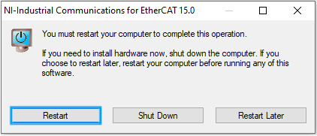The next screen will prompt a restart to complete the operation. Press “Restart” to continue.

## **LabVIEW 2019**

1. Navigate to \\c1315mv65\groups\Private\TestSupport\JADEC Commissioning\Software\National Instruments.
2. Open the Folder “NationalInstruments_LabVIEW2019_19.0”
3. Open the Folder “Files”
4. 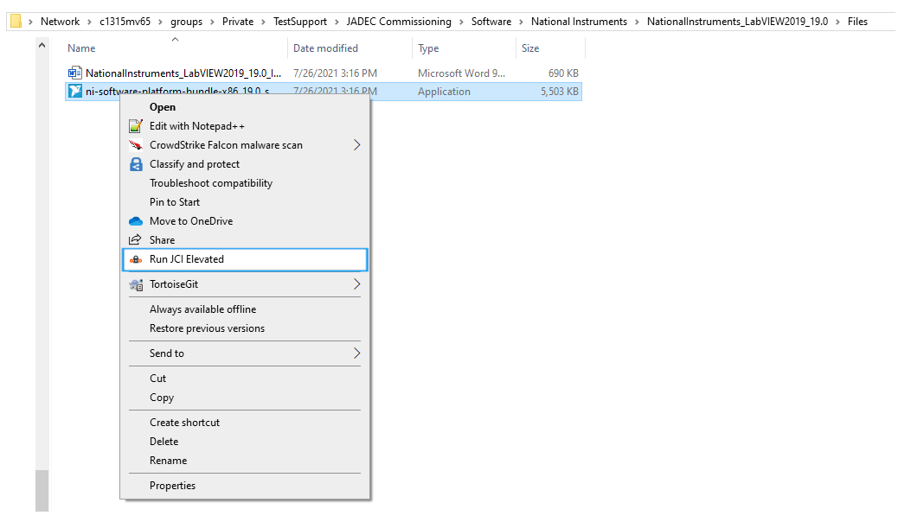Right click on “ni-software-platform-bundle-x86_19.0_suite_online_repack” and select “Run JCI Elevated”
5. 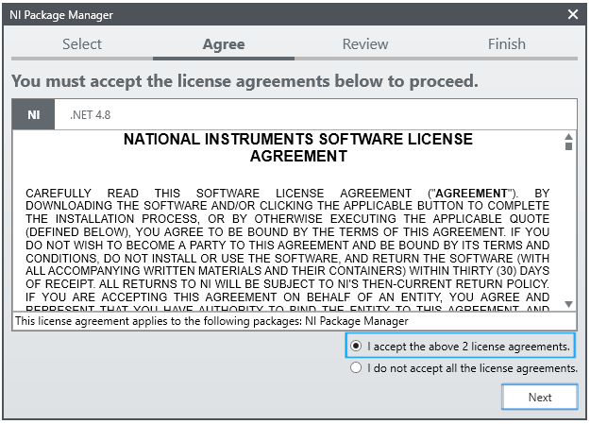A “NI Package Manager” Window will open prompting the user to accept License Agreements. Select “I accept the above License Agreements.” And Press “Next” to proceed.
6. 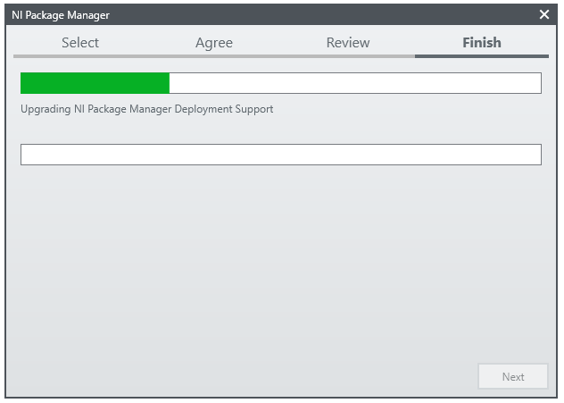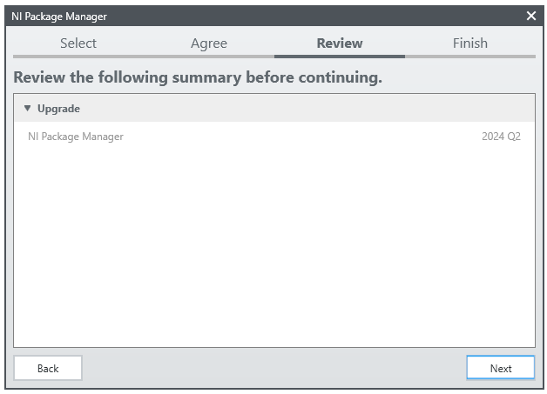The next screen will review a summary of what will be installed. Press “Next” to continue.
7. 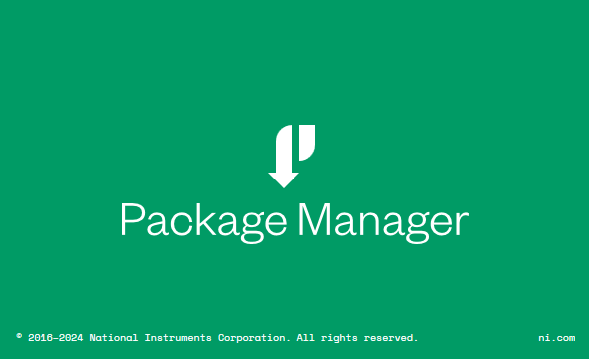The next screen will install “NI Package Manager” Please, Wait until the instal finishes.
8. 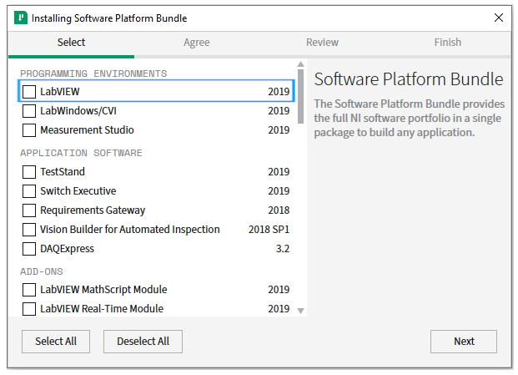Once the “NI Package Manager Installation” completes, the “Software Platform Bundle” installer will start. Uncheck “LabVIEW 2019”.
9. 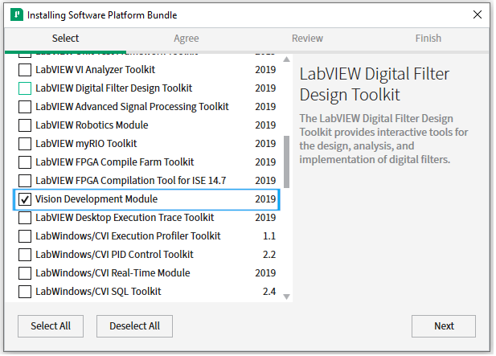Scroll down and select “Vision Development Module”.
10. 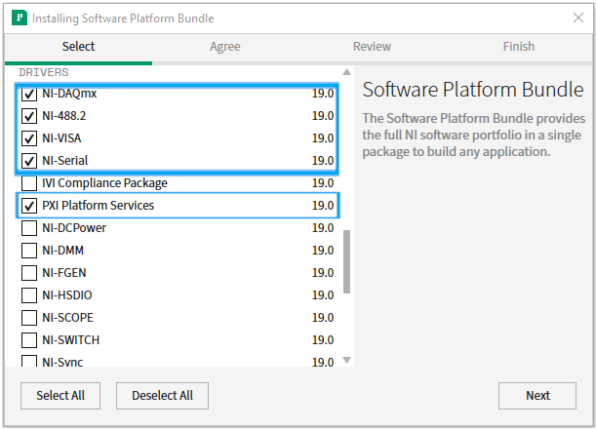Scroll down and select “NI-DAQmx”, “NI-488.2”, “NI-VISA”, “NI-Serial”, and “PXI Platform Services”.
11. 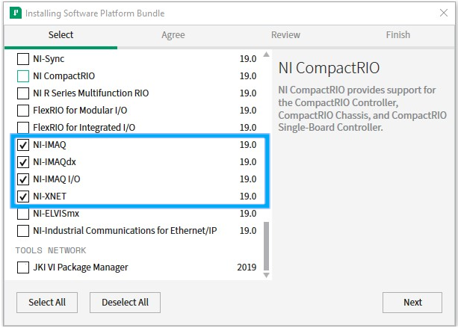 Scroll down and select “NI-IMAQ”, “NI-IMAQdx”, “NI-IMAQ I/O”, and “NI-XNET”. Press “Next” to proceed.
12. 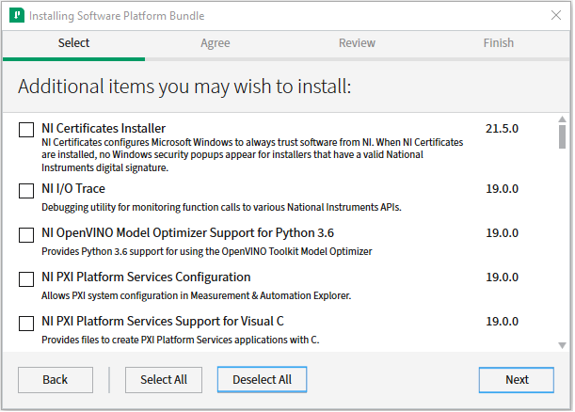The next screen will prompt for additional items. Press “Deselect All” and then “Next” to proceed.
13. 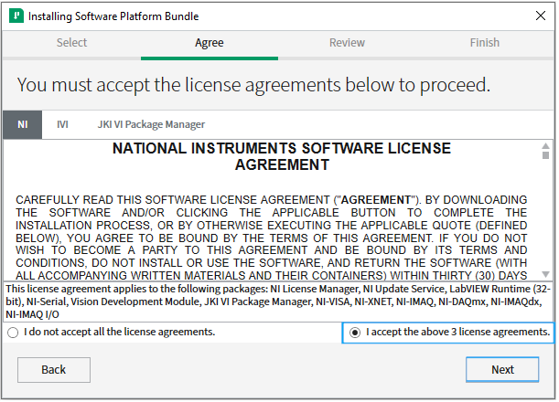The next screen will prompt to accept license agreements. Select “I accept the above x license agreements” and press “Next” to proceed.
14. 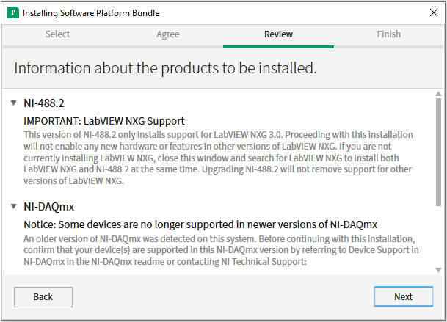The next screen will show “Information about the products to be installed”. Press “Next” to proceed.
15. 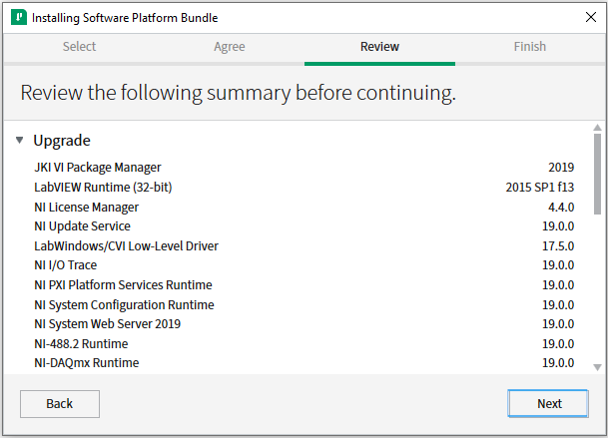The next screen will prompt the user to review the software being installed. Press “Next” to proceed.
16. 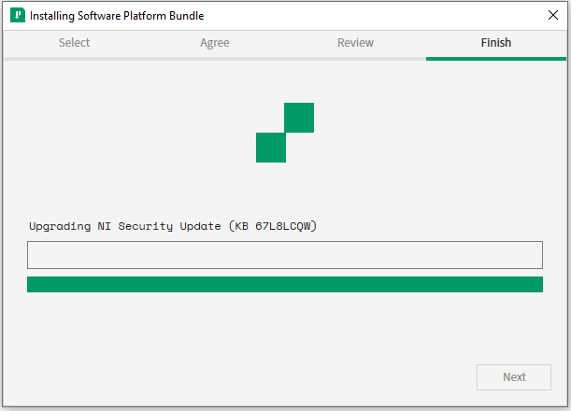Next, the “Software Platform Bundle” will begin to install. Please, wait for the installation to finish.
17. 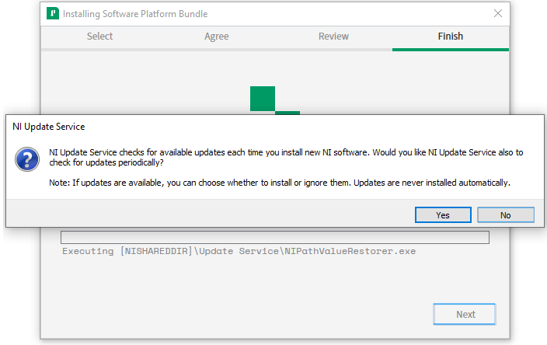During installation, there will be a prompt to have “NI Update Service” check for updates each time new software is installed. Press “No” to proceed.
18. 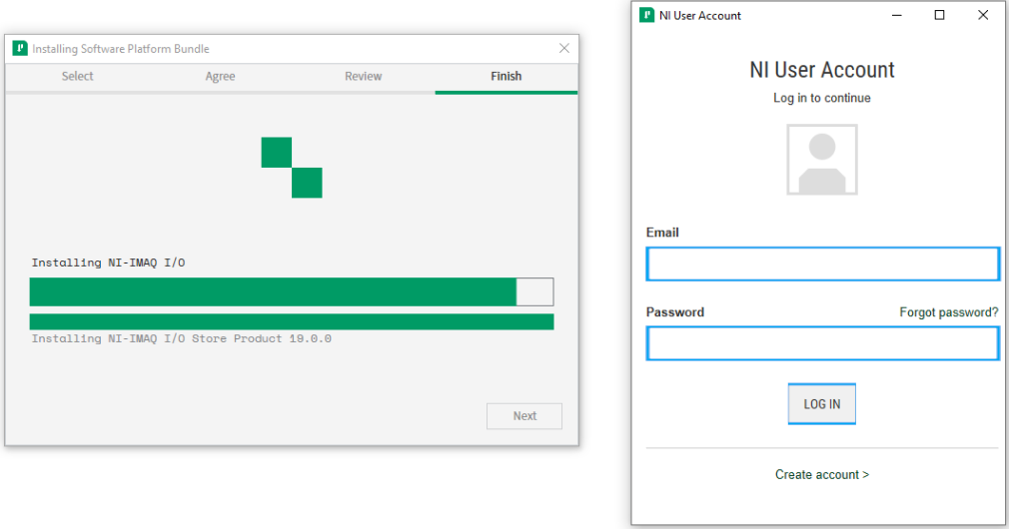Durning installation a window will prompt the user to log in to their NI Account. Please enter the username and password and press “Log In”
19. 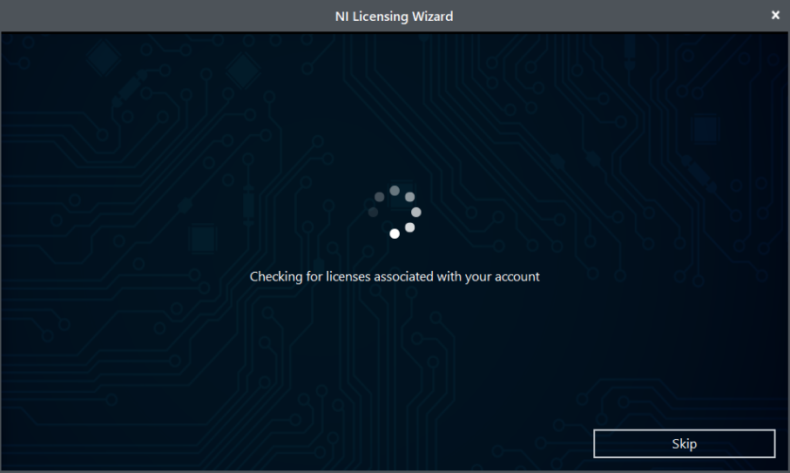After Log in, “NI Licensing Wizard” will run. Wait for a window to open prompting for serial numbers.
20. 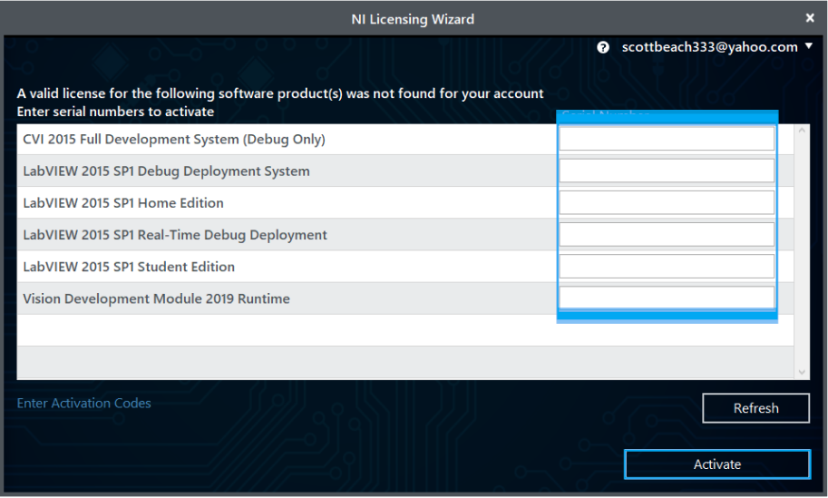When the “NI License Wizard” prompt for serial numbers comes up, verify the serials are entered from the NI account or enter them. Press “Activate” to proceed. Some items may not activate. If they come up with errors, just proceed past them.
21. 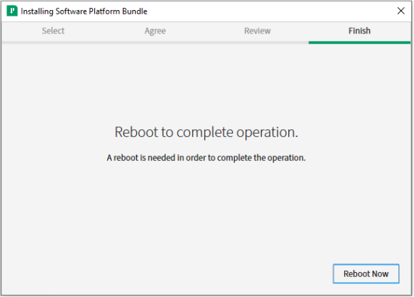After activation a Reboot will be needed. Press “Reboot Now” to proceed.

## **NI Compact RIO 18.1**

1. Navigate to \\c1315mv65\groups\Private\TestSupport\JADEC Commissioning\Software\National Instruments.
2. Open Folder “NICRIO1810”
3. 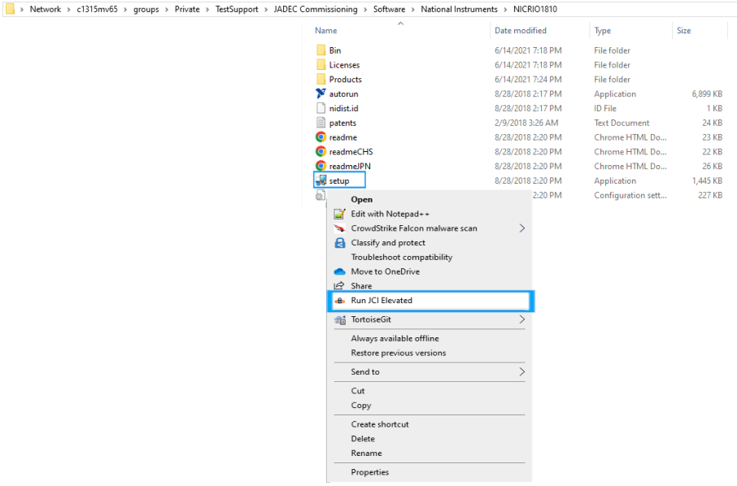Right click on “Setup” and select “Run JCI Elevated”.
4. 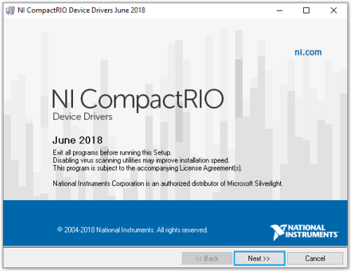“NI Compact RIO Device Drivers June 2018” installer will load. Press “Next” to proceed.
5. 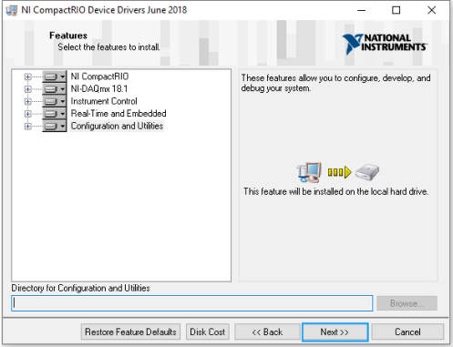The next screen will prompt the users to “Select the features to install.” Keep all defaults and press “Next” to proceed.
6. 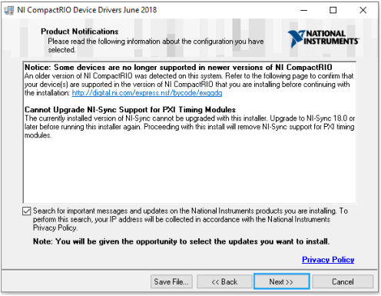The next screen will prompt the user with some notifications and to “Search for important messages and updates”. Verify the search box is selected and press “Next” to proceed.
7. 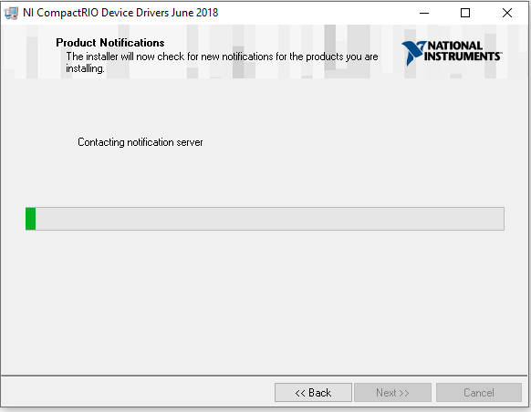The installer will then search for the messages and updates. Please, wait until this operation is complete.
8. 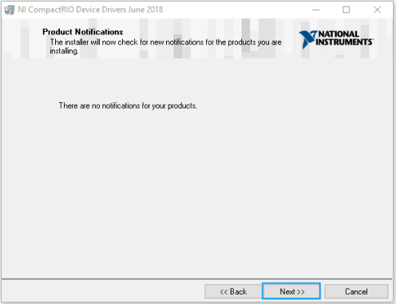There should be no notificastions. Press “Next” to proceed.
9. 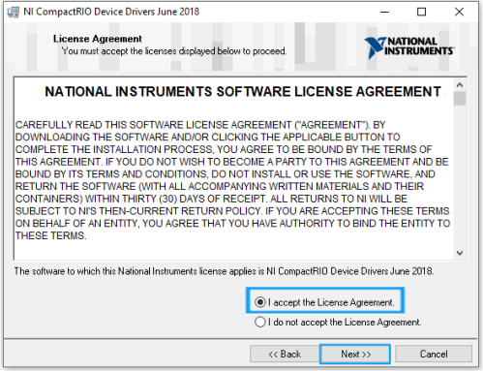The next screen will prompt for license agreements. Select “I accept the License Agreement” and press “Next” to proceed.
10. 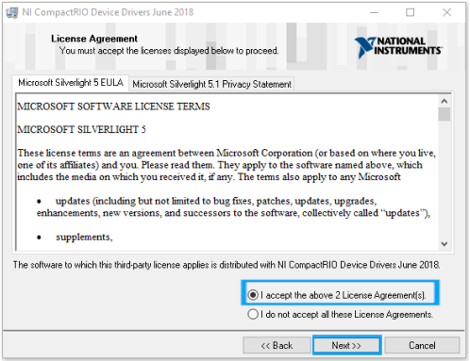Then next screen will prompt for additional license agreements. Verify “I accept the above 2 license Agreement(s). and press “Next” to proceed.
11. 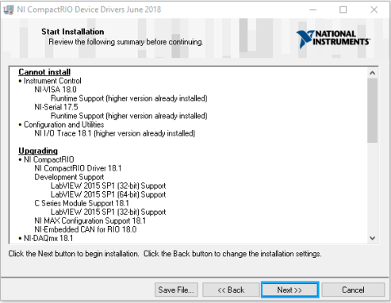The next screen will prompt to “Start installation”. Press “Next” to proceed.
12. 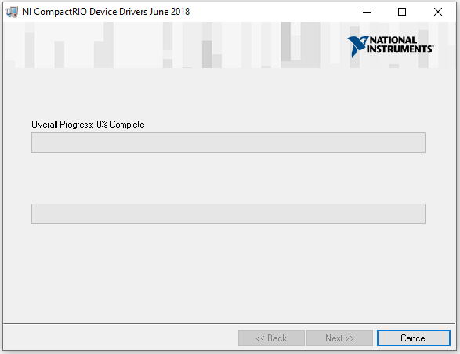Installation will now begin. Please, wait for the installation to complete.
13. 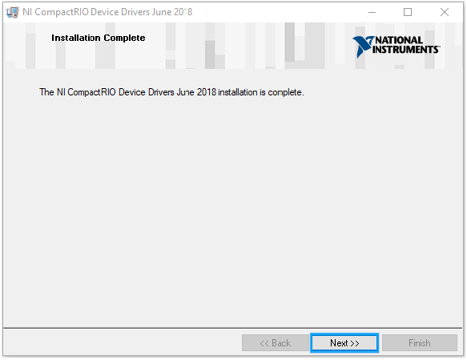Upon installation completion, a prompt will notify the user that “The NI CompactRIO Device Drivers June 2018 installation is complete”. Press “Next” to proceed.
14. 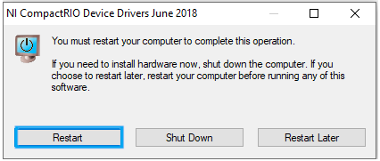To complete the installation the PC, will need to reboot. The installation will prompt the user to do so. Press “Restart” to proceed.

## **NI-Industrial Communications for EtherCAT 18.0.0**

1. Navigate to \\c1315mv65\groups\Private\TestSupport\JADEC Commissioning\Software\National Instruments.
2. Open the Folder “NI-Industrial Communications for EtherCAT”
3. Open the Folder “18.0.0”
4. 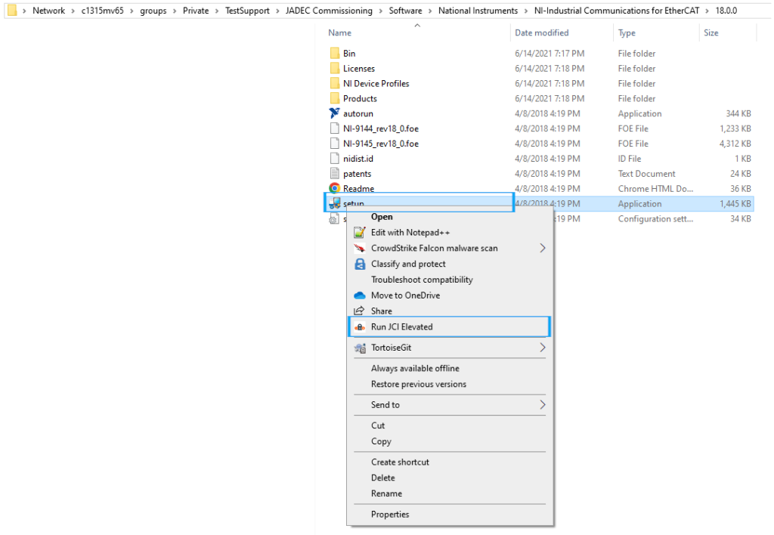Right click on “Setup” and select “Run JCI Elevated”
5. 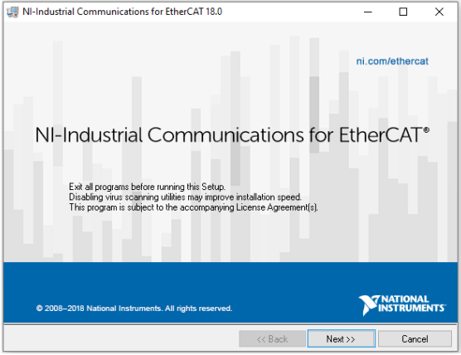“NI-Industrial Communications for EtherCAT 18.0” Installer window will now load. Press “Next” to proceed.
6. 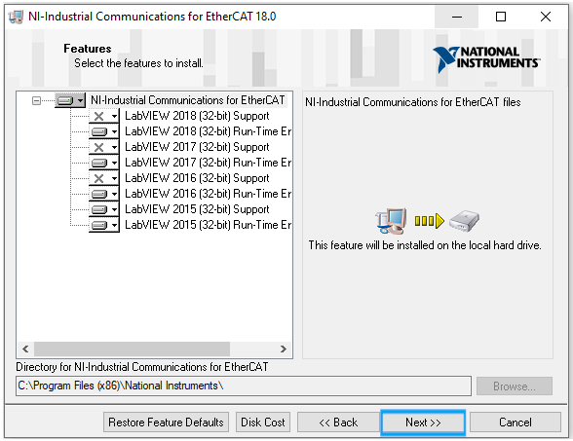The next screen will prompt to “Select the features to install.” Keep selections to default and press “Next” to proceed.
7. 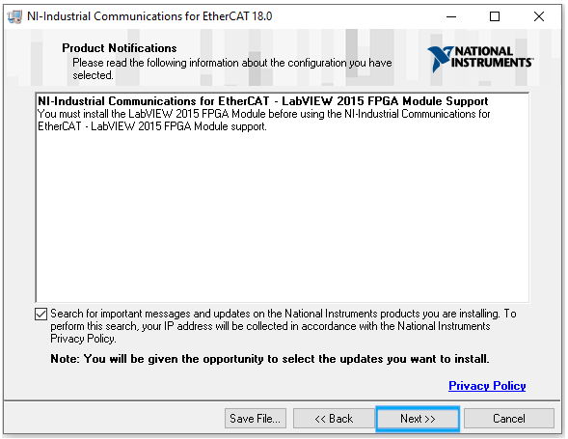The next screen will prompt the user to check notifications and “Search for important messages and updates”. Verify “Search is checked” and press “Next” to proceed.
8. 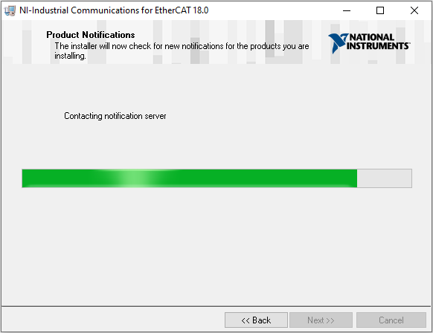The installer will now search. Please wait until the search finishes.
9. 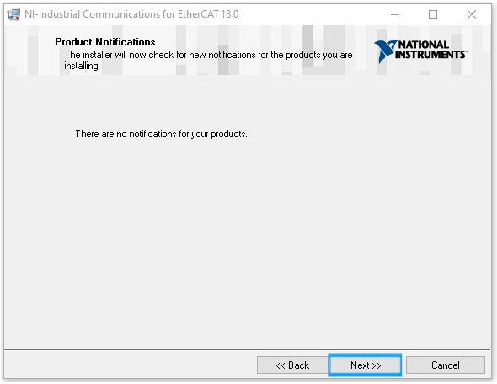There should be no notifications. Press “Next” to proceed.
10. 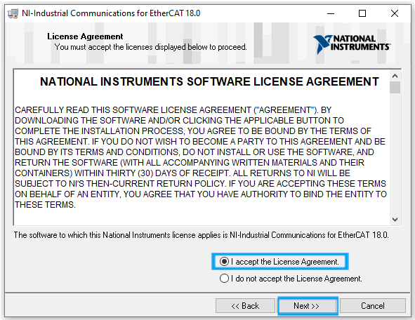The next screen will be a license agreement acceptance. Please select “I accept the License Agreement” and press “Next” to proceed.
11. 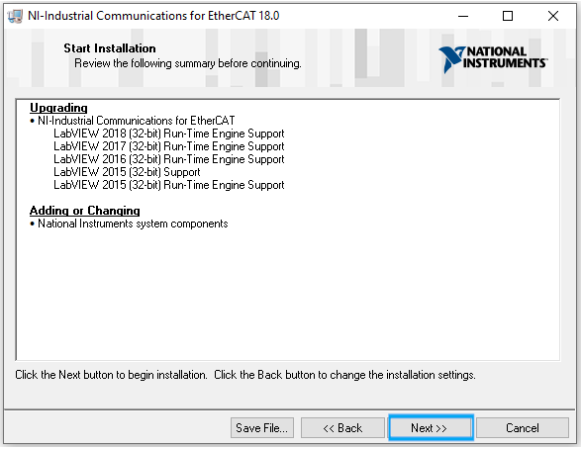The next screen will prompt to start installation. Press “Next” to proceed.
12. 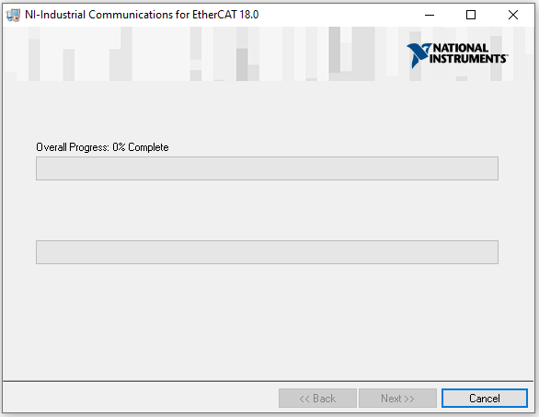Installation will now begin. Please, wait for installation to complete.
13. 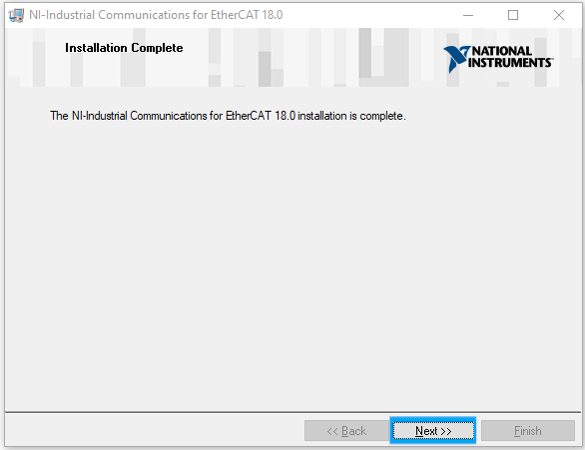After installation, a prompt will come up saying “Installation Complete”. Press “Next” to proceed.
14. 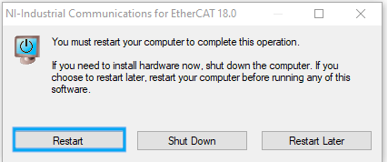The next screen will prompt the user to restart to finish complete the operation. Press “Restart” to proceed.

## **NI Update Post NI-Industrial Communications for EtherCAT 18.0.0 Install**

1. On Windows Start Search type “NI Update Service” and select “NI Update Service”.
2. The window will then search NI.com for Updates.
3. 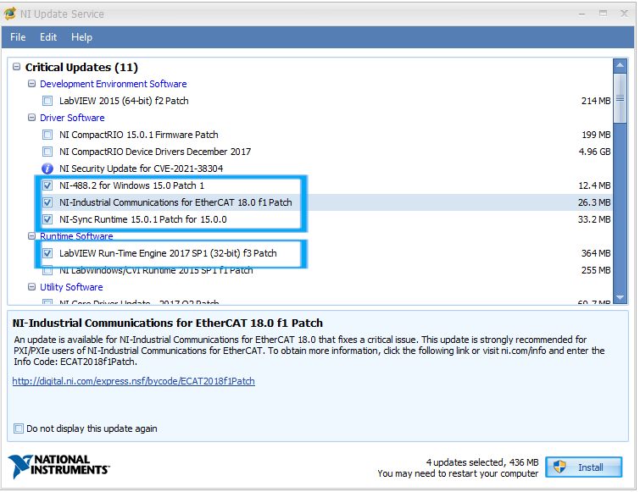When updates are found, select “NI-488.2 for Windows 15.0 Patch”, “NI-Industrial Communications for EtherCAT 18.0 f1 Patch”, “NI-Sync Runtime 15.0.1 Patch for 15.0.0”, and “LabVIEW Run-Time Engine 2017 SP1 (32 bit) f3 Patch”. Press “Install” to proceed.
4. 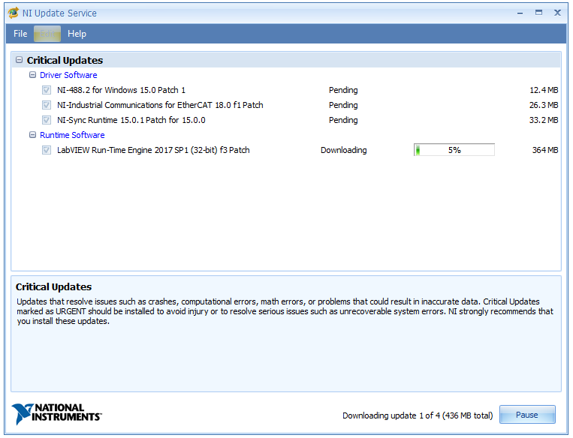Install will begin. Please, wait for further instructions or completion.
5. 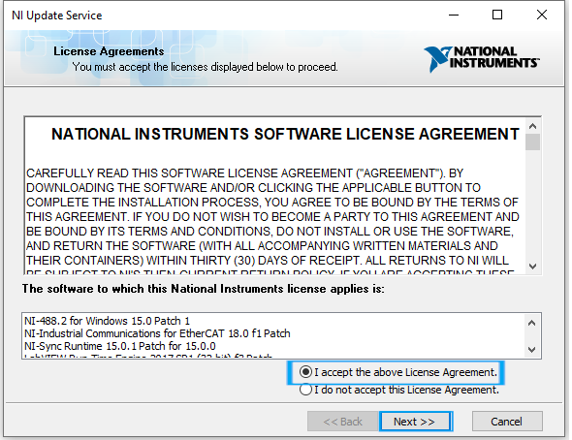A License Agreement will come up during installations. When it does, select “I accept the above Liocense Agreement” and press “Next” to proceed.
6. 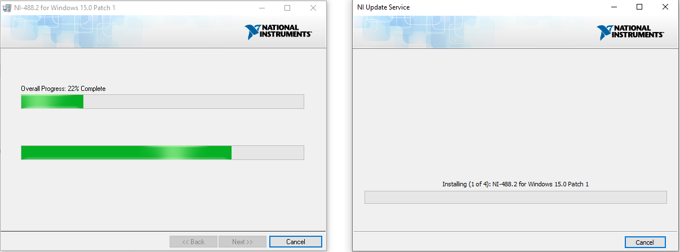Installation will continue. Please, wait for installation to complete.
7. 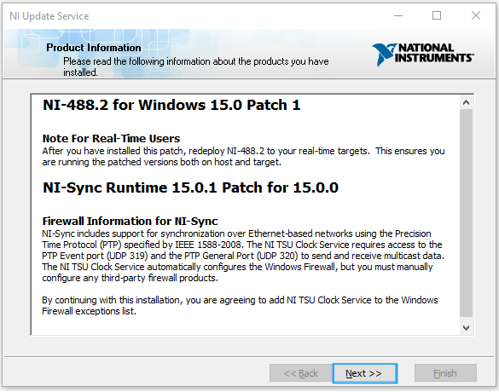After installation a screen will come up with product information for what was installed. Press “Next” to proceed.
8. 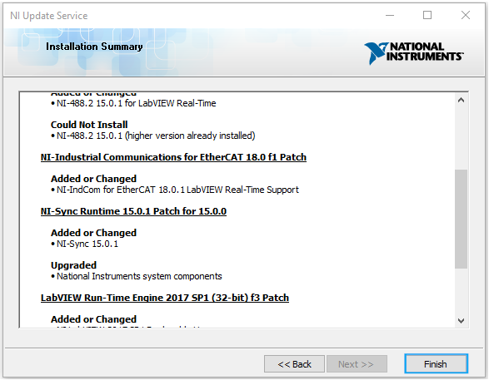Next will be an installation summary going over what was installed and the actions taken. Press “Finish” to proceed.
9. 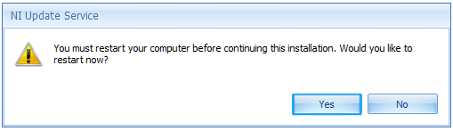A screen will come up prompting the user to restart to finish the installation. Press “Yes” to restart.

## **NI-CAN**

1. Navigate to \\c1315mv65\groups\Private\TestSupport\JADEC Commissioning\Software\National Instruments.
2. Open the Folder “NationalInstruments_LabVIEW2019_19.0”
3. Open the Folder “NI-CAN”
4. Open the Folder “15.0”
5. 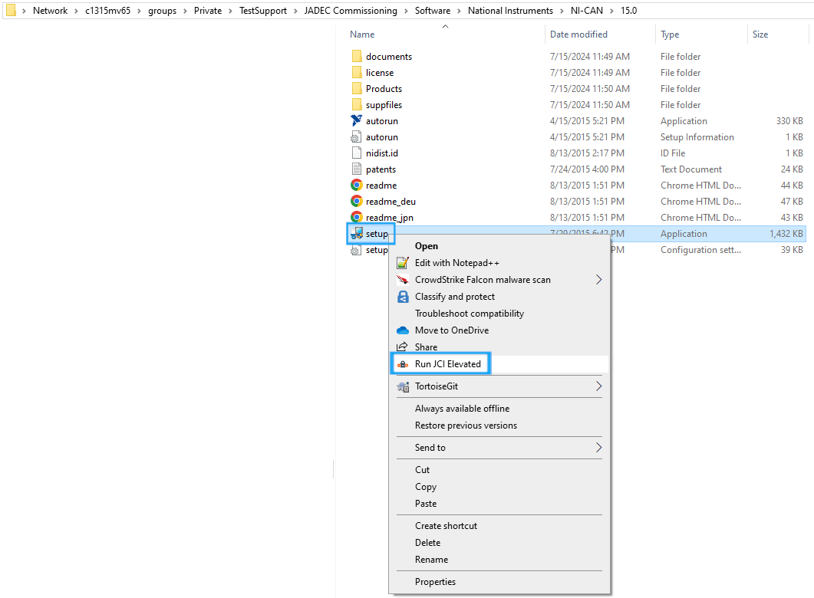Right click on “Setup” and select “Run JCI Elevated”
6. 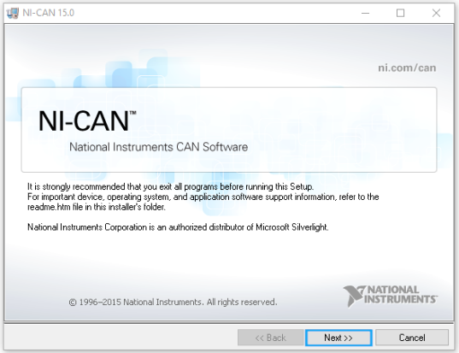The installer window for NI-CAN will load. Press “Next” to proceed.
7. 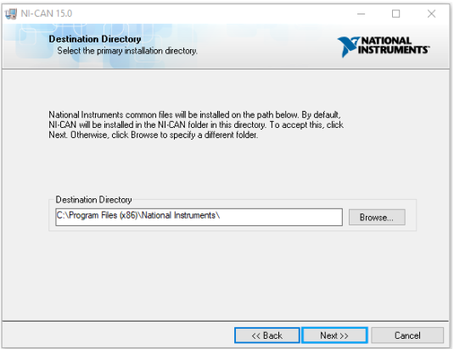The next screen will go over the destination directory. Keep the directory default and press “Next “ to proceed.
8. 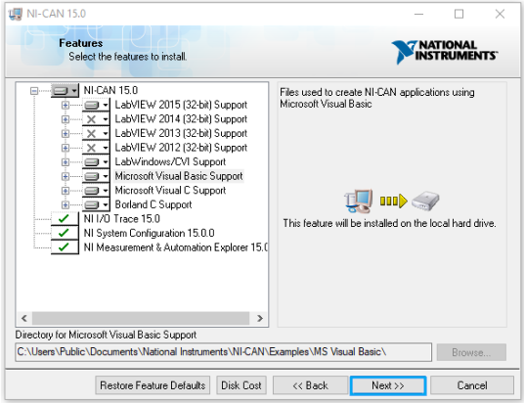The next screen will go over the features to install. Keep all default features and press “Next” to proceed.
9. 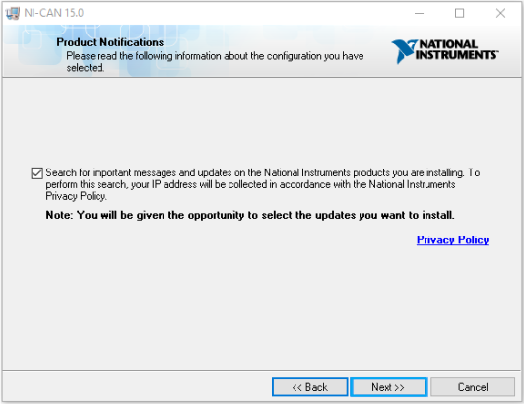The next screen will prompt the user to “Search for important messages and updates”. Select “Next” to proceed.
10. 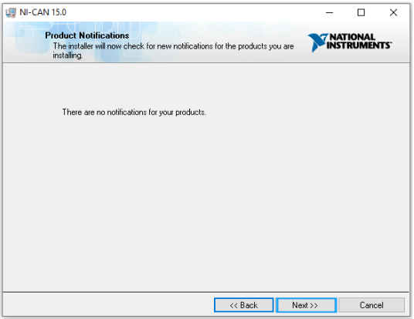There should be no updates. The next screen will tell the user this. Press “Next” to proceed.
11. 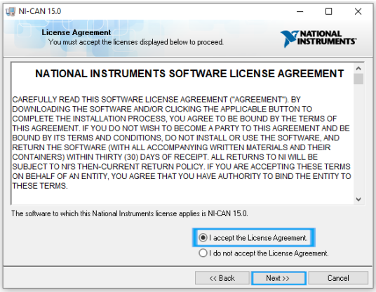The next screen will be the license agreement. Check “I accept the License Agreement” and press “Next’ to proceed.
12. 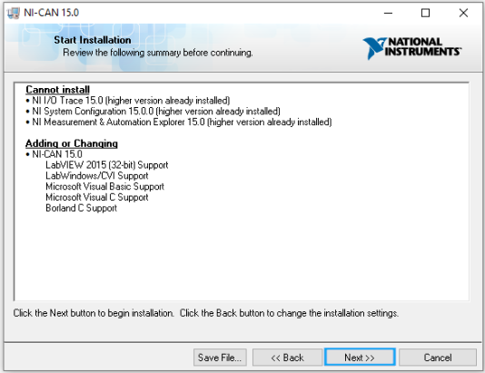The next screen will display what will be installed and prompt the user to start the installation. Press “Next” to proceed.
13. 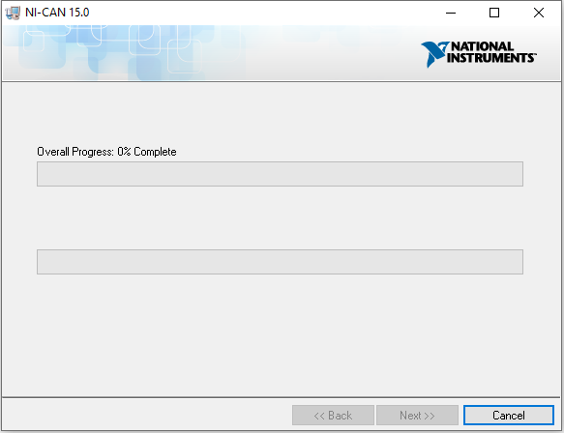Installation will now begin. Please, wait for installation to complete.
14. 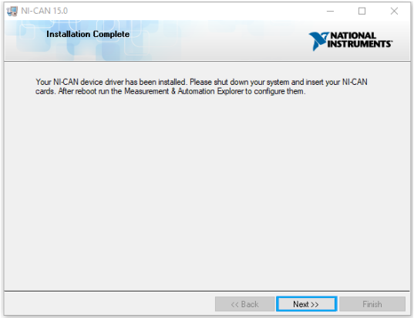After installation is complete, the next screen will show an installation complete prompt. Press “Next” to proceed.
15. 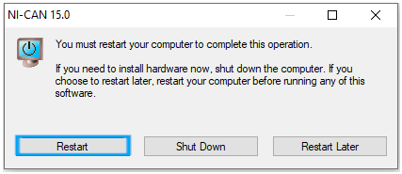A prompt for finalizing installation with a restart will now come display. Press “Restart” to proceed.

## **JKI Package Manager**

1. Navigate to \\c1315mv65\groups\Private\TestSupport\JADEC Commissioning\Software\National Instruments.
2. 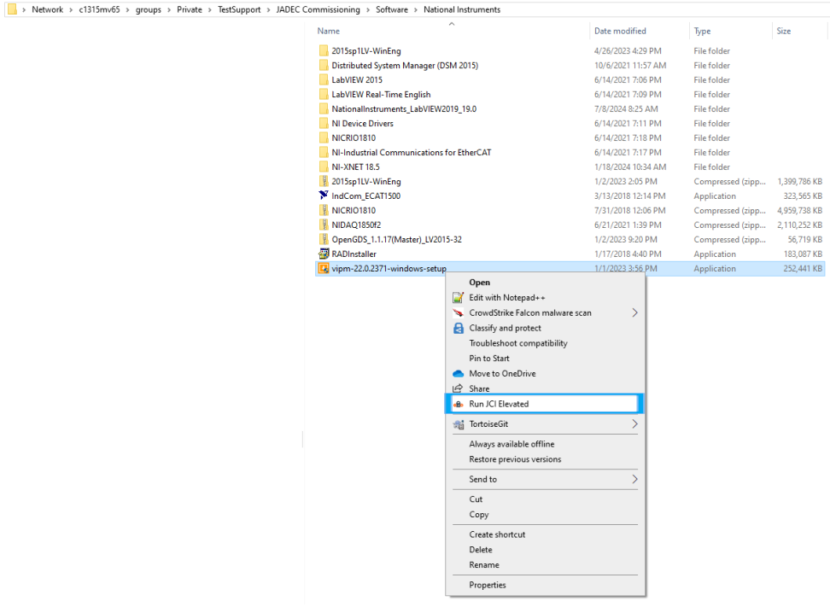Right click on “vipm-22.0.2371-windows-setup” and select "Run JCI Elevated”
3. 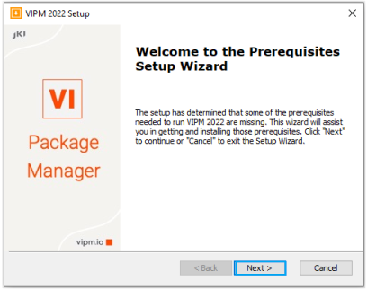JKI Package Manager installation will now begin. The first screen will prompt the user to download any “Prerequisites” that may have been missed during previous installs. Press “Next” to proceed.
4. 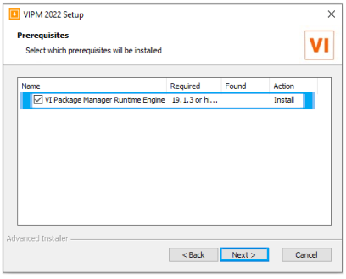The next screen will prompt the user to select the prerequisites that were not installed. Please verify all prerequisites are selected and press “Next” to proceed.
5. 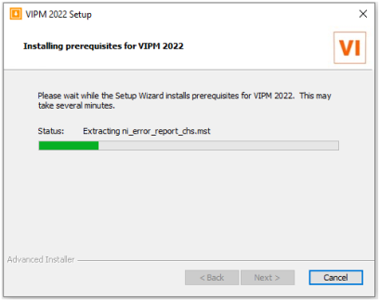The next screen will install the prerequisites. Please, wait for the installation to complete.
6. 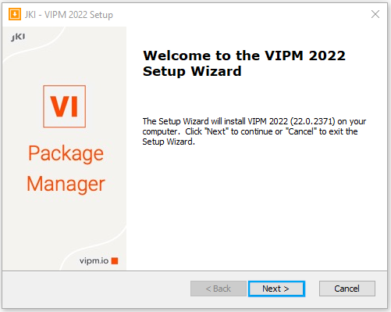Next, the VIPM 2022 Setup wizard will run. Press “Next” to proceed.
7. 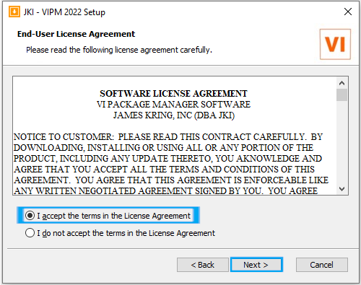The next screen will prompt for the user to accept the license agreement. Press “Next” to proceed.
8. 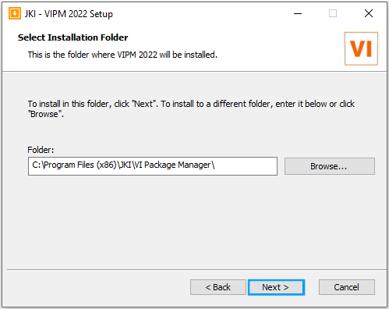The next screen will prompt the user to select the install location. For this location, use default. Press “Next” to proceed.
9. 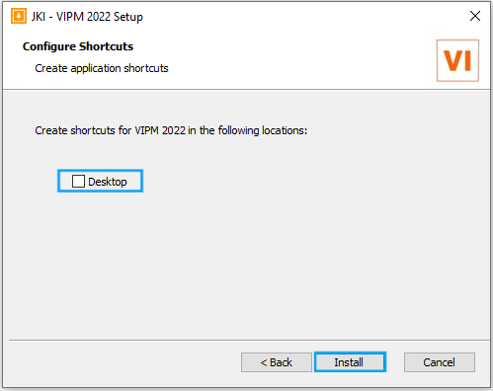A screen will come up prompting for configuration of shortcuts. Please uncheck “Desktop” and press “Install” to proceed.
10. 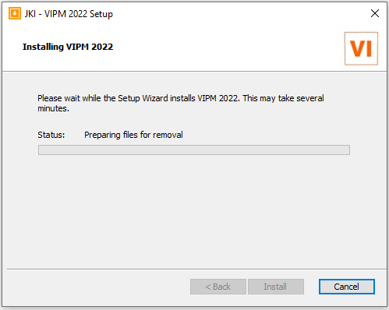VIPM will now install. Please, wait for installation to finish.
11. 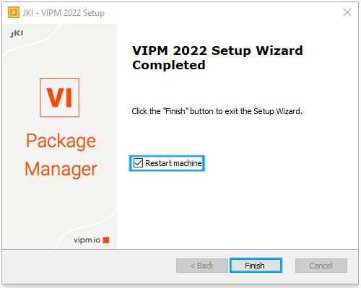After installation, the window will prompt the user for restart. Verify “Restart machine” is checked, and press “Finish” to proceed.

## **Open GDS**

1. Navigate to \\c1315mv65\groups\Private\TestSupport\JADEC Commissioning\Software\National Instruments.
2. Open Zip Folder “OpenGDS_1.1.17(Master)_LV2015-32.zip”
3. Open file “OpenGDS_1.1.17(Master)_LV2015-32”
4. 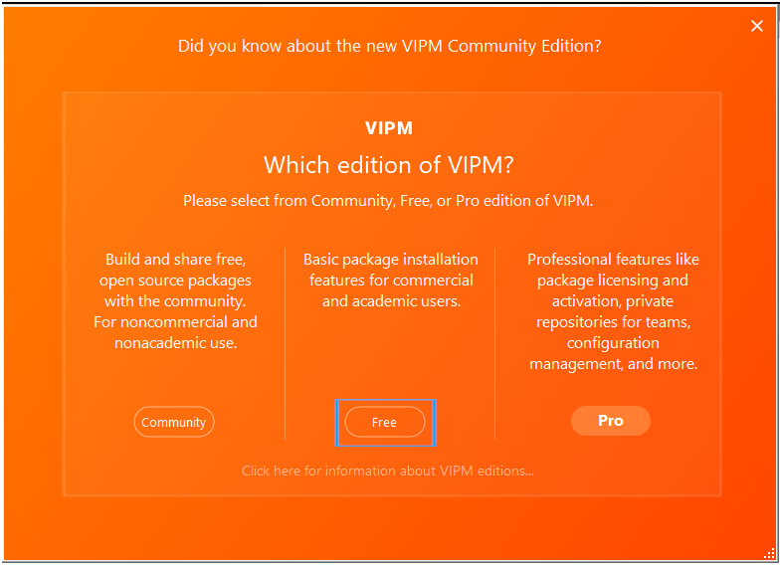This will be the first time VIPM is used so, it will need configured. Please select the “Free” edition to proceed.
5. 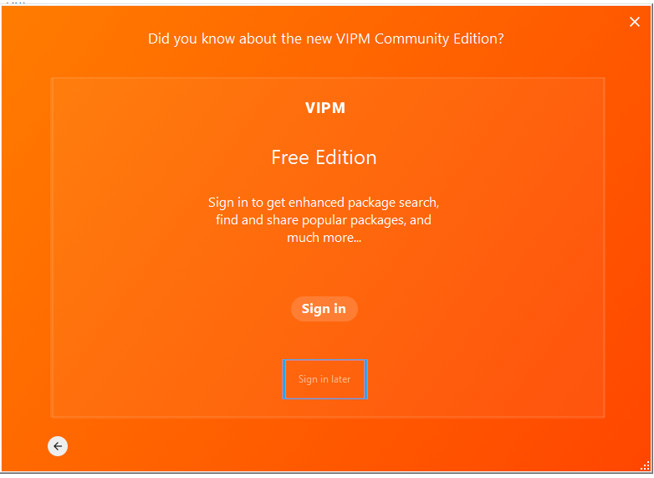The next screen will prompt the user to sign in. Press “Sign in later” to proceed.
6. 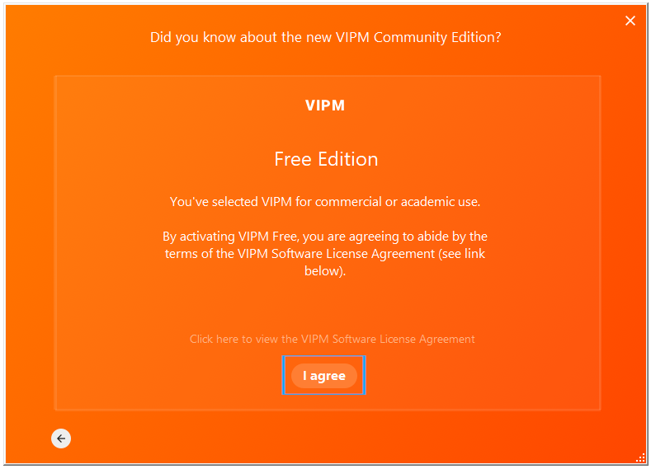The next screen will prompt the user to agree to terms of the license agreement. Press “I agree” to proceed.
7. 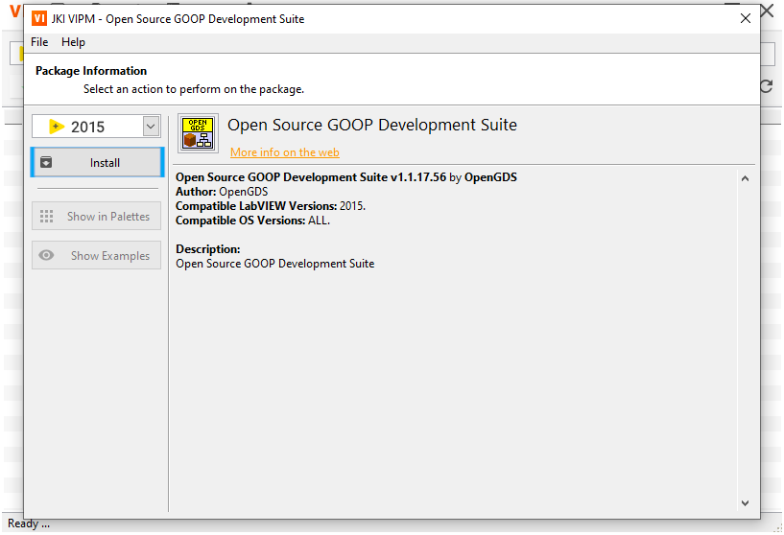Now, VIPM will open up, ready to install Open Source GOOP Development Suite. Press “Install” to begin installation.
8. 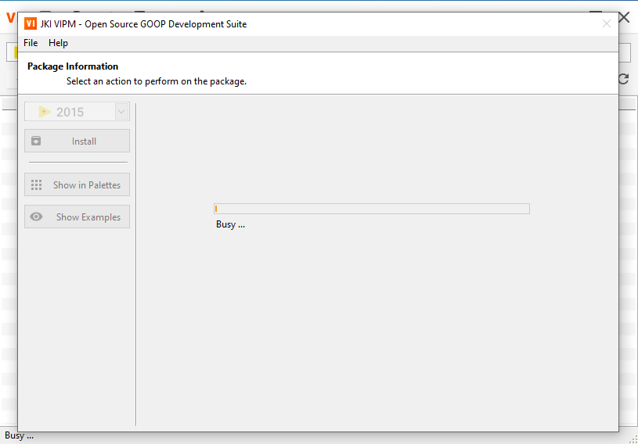Installation will now begin. Please, wait for installation to complete.
9. 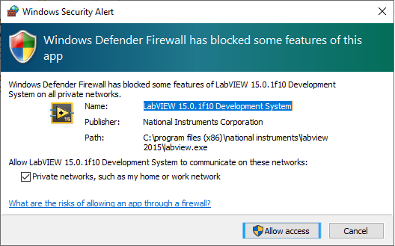During installation, a windows firewall prompt will come up. Press “Allow Access” to proceed.
10. 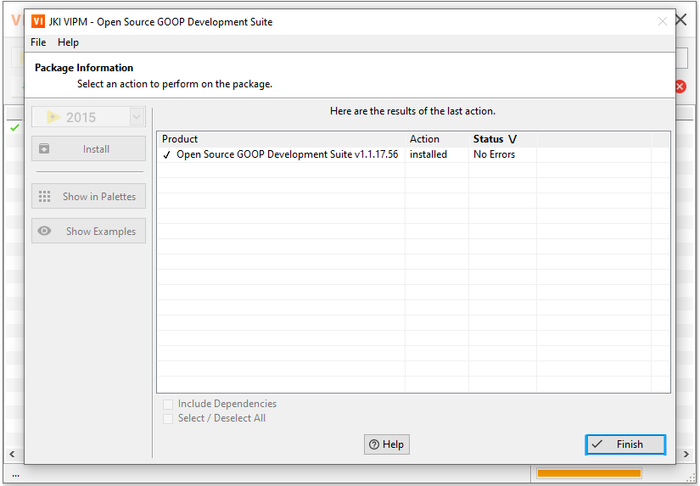When the installation finishes, the window will prompt the use. Press “Finish” to proceed.
11. 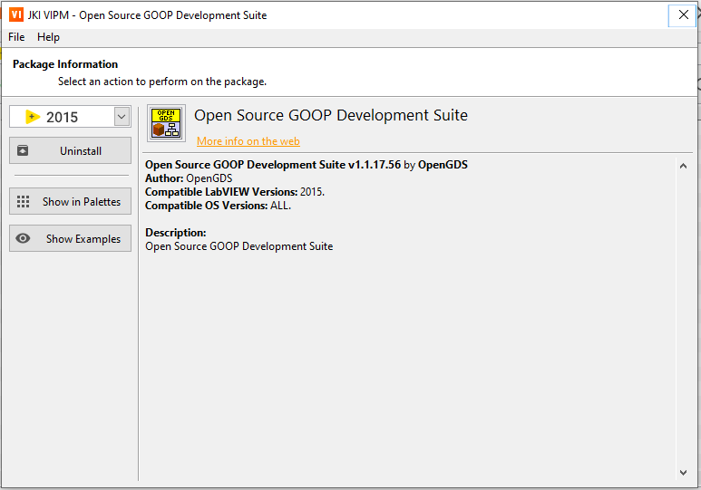Close the next window by pressing the “x” in the upper right corner of the window.

## **VIPM Installs**

### **OpenG**

1. 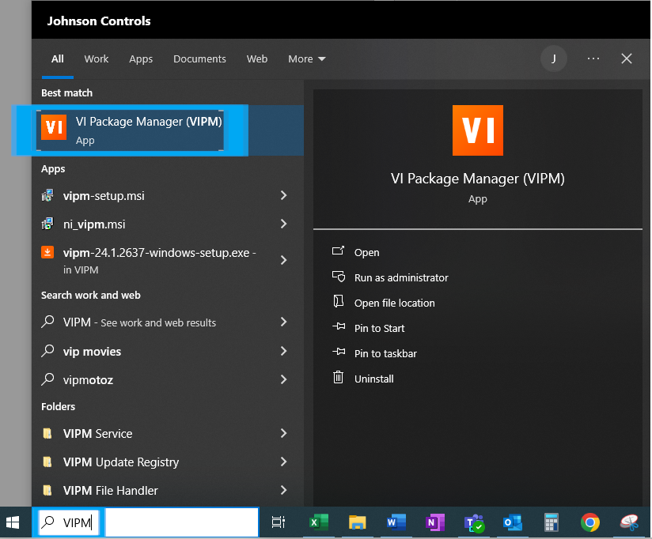In the windows start menu search, type in “VIPM” and click on VI Package Manager (VIPM).
2. 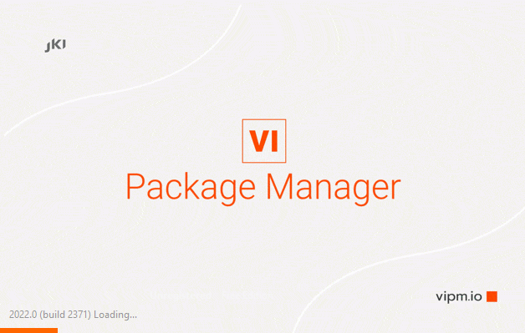VIPM will now load. Please wait for the program to load.
3. 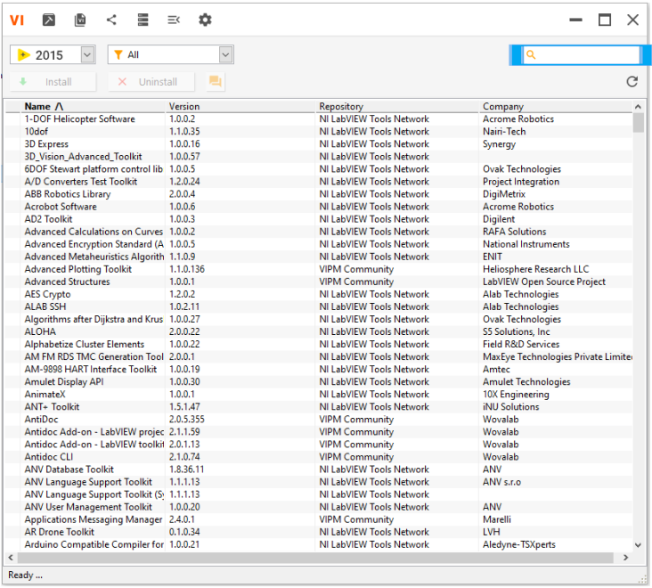VI Package Manager will load. The search will be used to find the software to install.
4. 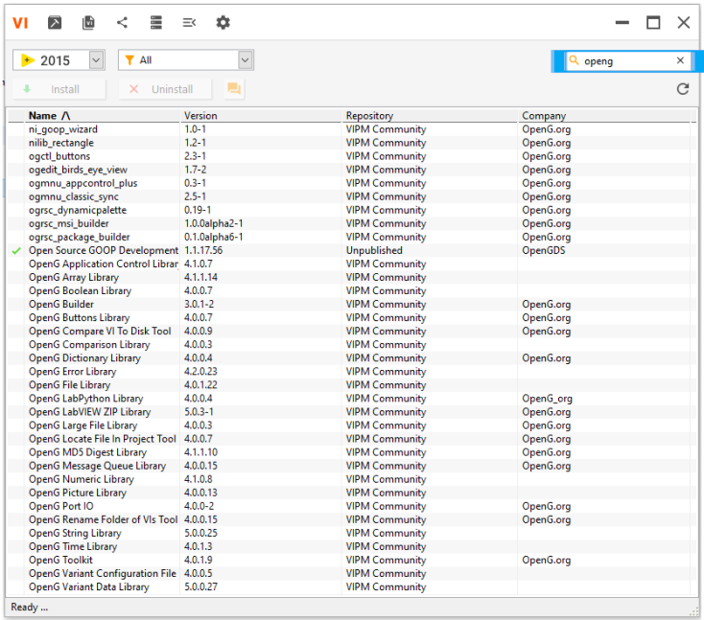Type “openg” into the search.
5. While Holding Control, Select
   1. OpenG Application Control Library
   2. OpenG Array Library
   3. OpenG Boolean Library
   4. OpenG Builder
   5. OpenG Buttons Library
   6. OpenG Compare VI To Disk Tool
   7. OpenG Comparison Library
   8. OpenG Dictionary Library
   9. OpenG Error Library
   10. OpenG File Library
   11. OpenG LabPython Library
   12. OpenG LabVIEW Data Library
   13. OpenG LabVIEW ZIP Library
   14. OpenG Large File Library
   15. OpenG Locate File In Project Tool
   16. OpenG MD5 Digest Library
   17. OpenG Message Queue Library
   18. OpenG Numeric Library
   19. OpenG Picture Library
   20. OpenG Port IO
   21. OpenG Rename Folder of VIs Tool
   22. OpenG String Library
   23. OpenG Time Library
   24. OpenG Toolkit
   25. 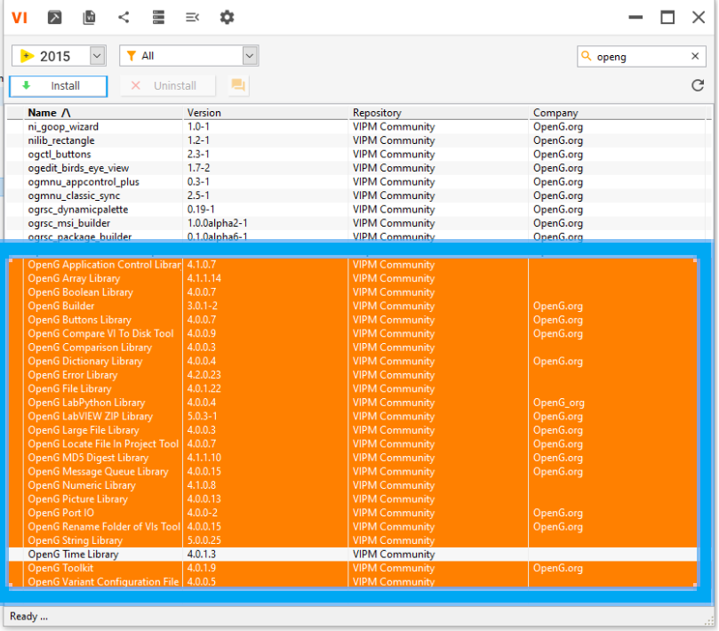OpenG Variant Configuration File Library
   26. Then, press “Install”
6. 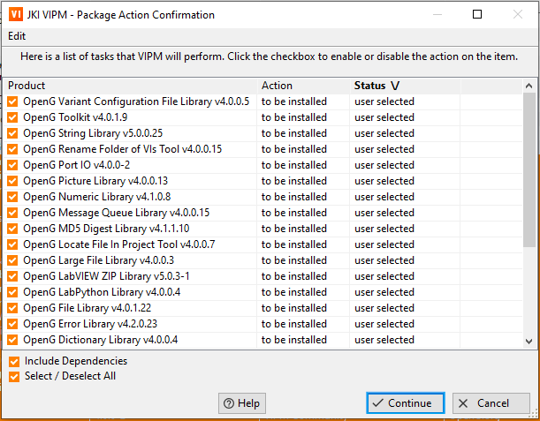A window will come up confirming the software to install. Press “Continue” to proceed.
7. 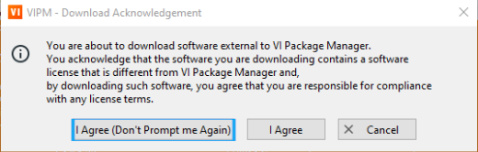Another window will come up asking the user to agree to the license for the software. Press “I Agree” to proceed.
8. 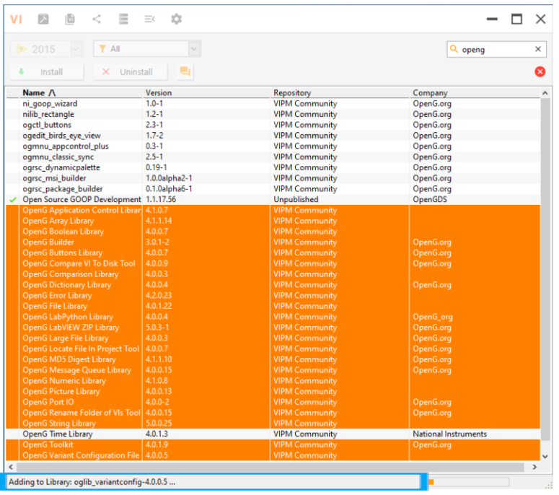Install will begin. Progress can be seen at the bottom of the window. Please, wait while the installation completes.
9. 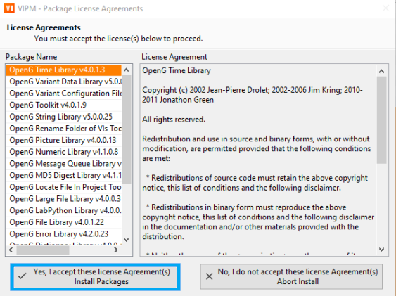Another License agreement will come up at some point. Press “Yes, I accept” to proceed.
10. 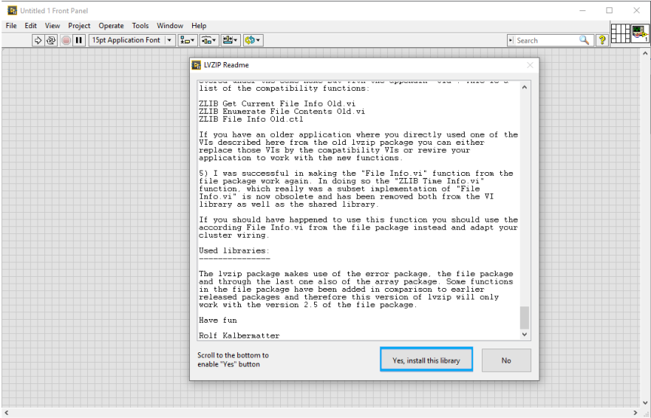During installation, LabVIEW 2015 will load. A window titled “LVZIP Readme” will come up. Scroll to the bottom of this window and press “Yes, install this library” to proceed.
11. 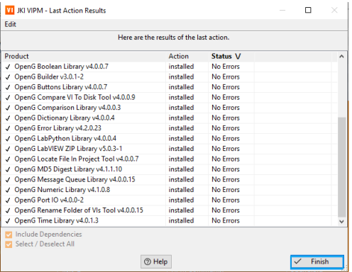Upon successful installation, a “Last action Results” window will come up. There should be no errors on any of the products. Press “Finish” to proceed.

### **MGI**

1. In the windows start menu search, type in “VIPM” and click on VI Package Manager (VIPM).

1. VIPM will now load. Please wait for the program to load.
2. VI Package Manager will load. The search will be used to find the software to install.
3. 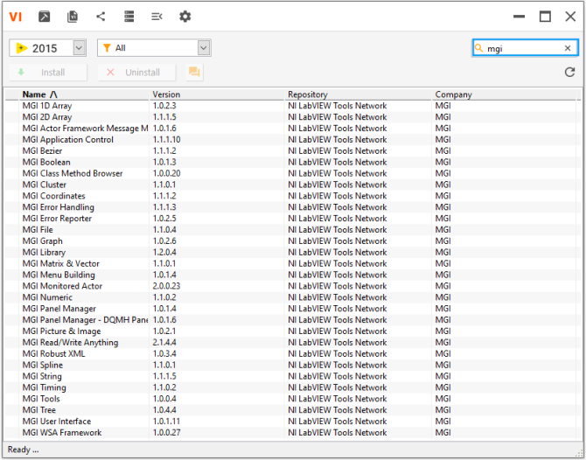Type “MGI” into the search.
4. 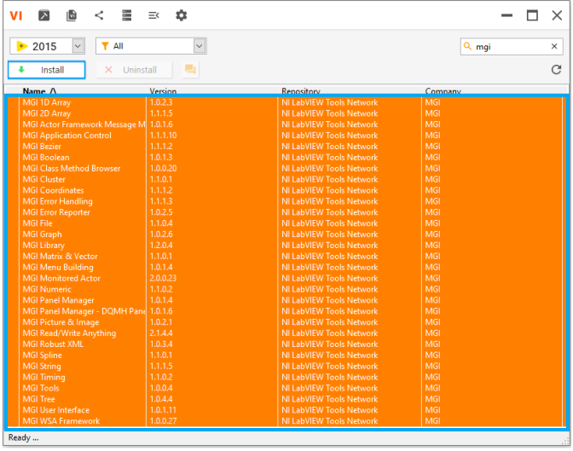Select all visible MGI Products and press “Install” to proceed.
5. 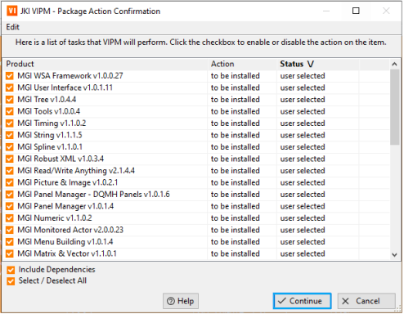VIPM will then prompt the user to confirm the products. Press “Continue” to proceed.
6. 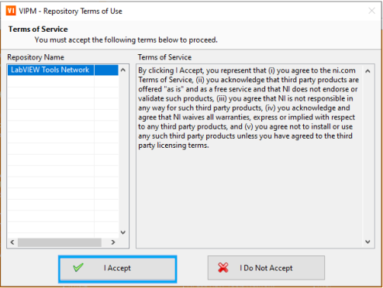A terms of service prompt will now pop up. Press “I Accept” to proceed.
7. 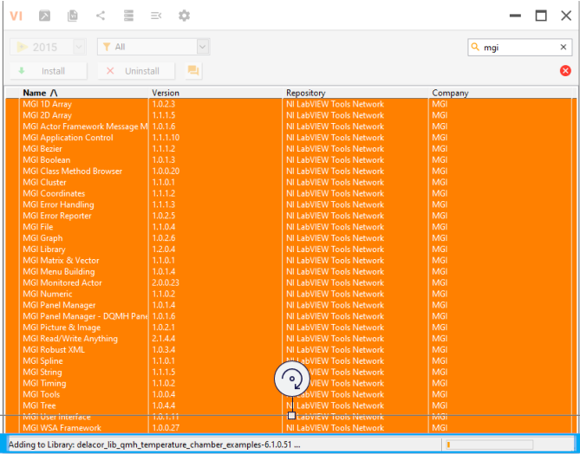Installation will now begin and can be tracked on the bottom of the VIPM window. Please, wait for further instructions.
8. 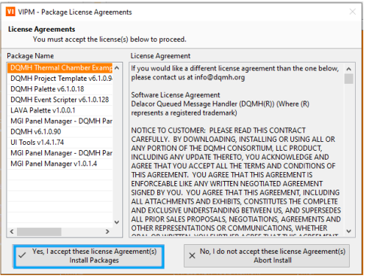A License Agreement prompt will load. Press “Yes, I accept” to proceed.
9. 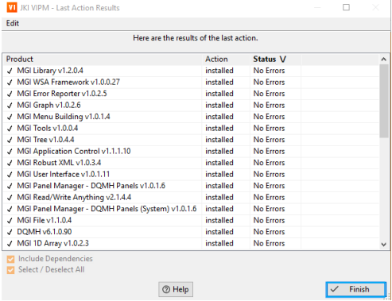Upon install completion, a window will come up showing the results. There should be no errors. Press “Finish” to proce**GPower**

1. In the windows start menu search, type in “VIPM” and click on VI Package Manager (VIPM).

1. VIPM will now load. Please wait for the program to load.
2. VI Package Manager will load. The search will be used to find the software to install.
3. Type “Gpower” into the search. Select:
   1. GPower All Toolsets
   2. GPower Array
   3. Gpower Array Library
   4. GPower Comparison
   5. GPower Error & Warning
   6. GPower Events
   7. GPower Math
   8. GPower Numeric
   9. GPower Overflow
   10. GPower String
   11. GPower Timing
   12. GPower VI Launcher
   13. GPower VI Register
   14. 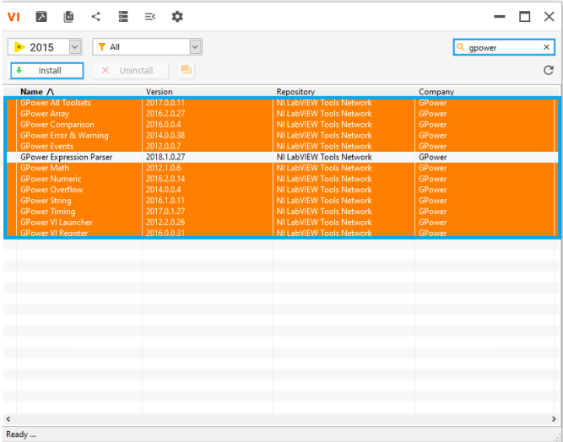Press “Install
4. 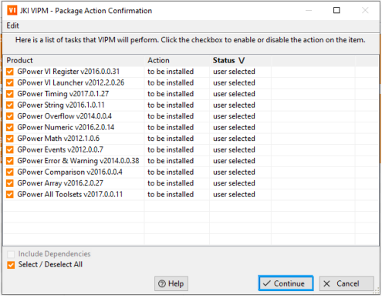A VIPM “Action Confirmation” Window will come up. Press “Continue” to proceed.
5. 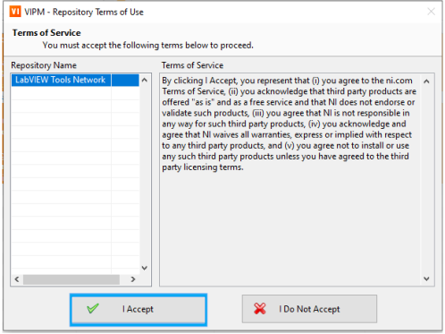Another window will come up going over “Terms of Service”. Press “I accept” to continue.

1. 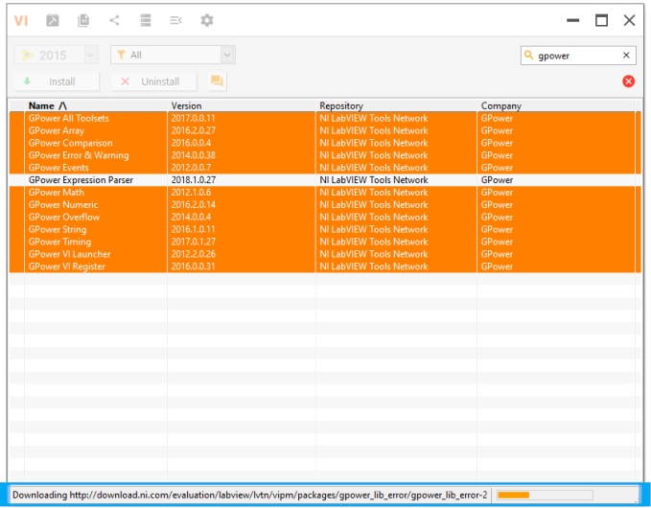Installation will begin. Status will be updated at the bottom of the window. Please wait for further instructions.
2. 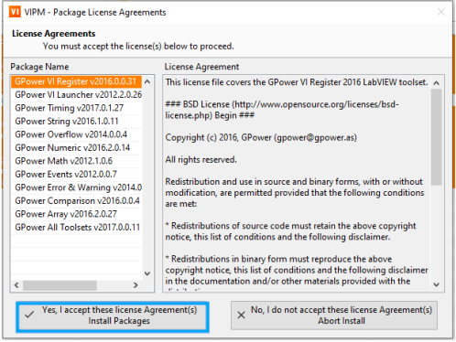A license agreement window will load. Press “Yes, I accept” to proceed.
3. 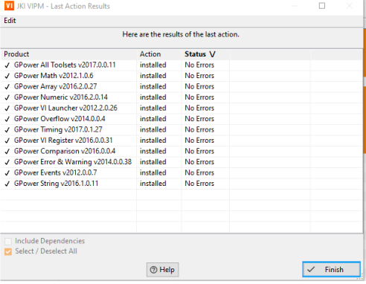Upon completion, a window will load showing the results. There should be no errors. Press “Finish” to proceed.

### **Misc VIPM Packages**

1. In the windows start menu search, type in “VIPM” and click on VI Package Manager (VIPM).

1. VIPM will now load. Please wait for the program to load.
2. VI Package Manager will load. The search will be used to find the software to install.
3. Type in the software from the list below, find the version, select it, install it, accept any license agreements, and complete installation. Instructions should be very similar to previous packages.
   1. jki_rsc_toolkits_palette Version 1.1-1
   2. NI Asynchronous Message Communication (AMC) Library Version 3.3.1.22
   3. NI CompactRIO Information (CRI) Library Version 2015.0.0.1
   4. NI GXML Version 1.4.2.8
   5. NI Modbus Library Version 1.2.1.42
   6. Structure Error Handler Version 2.1.10.1

### **Downgrading Installed Packages**

1. In the windows start menu search, type in “VIPM” and click on VI Package Manager (VIPM).

1. VIPM will now load. Please wait for the program to load.
2. VI Package Manager will load. The search will be used to find the software to install.
3. 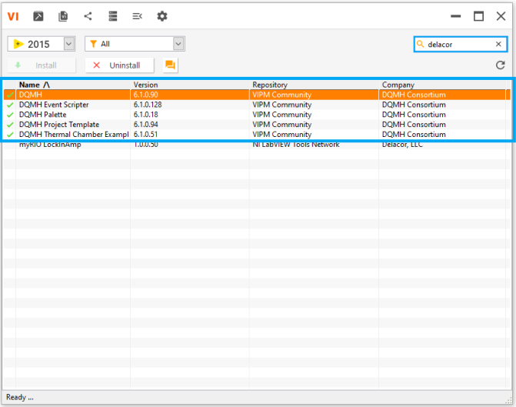Type ”Delacor” into the search.
4. 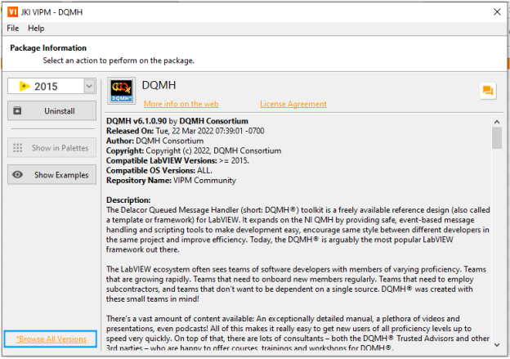The version installed will be newer than needed. They will need to be downgraded. Double click DQMH. A window will appear showing details about the product installed. Select “*Browse All Versions” in the bottom left corner.
5. 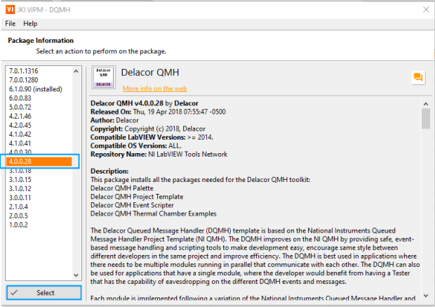Select Version 4.0.0.28 and press “Select” to proceed.
6. 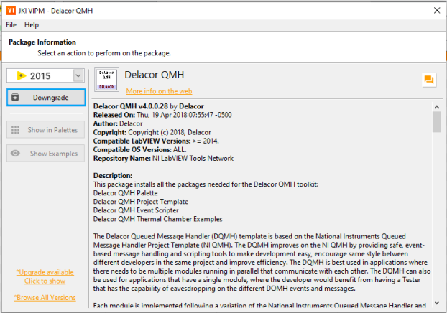For the next window, select “Downgrade” to proceed.
7. 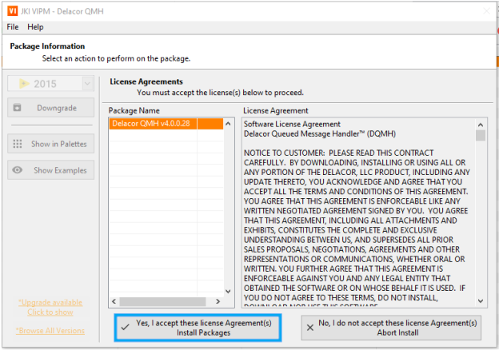The next screen will prompt the user to accept license agreements. Press “Yes, I accept” to proceed.
8. After installation, the next screen will show the actions. There should be no errors. Press “Finish” to proceed.
9. Repeat steps 4-9 with the remaining products:
   1. Delacor QMH Event Scripter Downgrade to 4.0.0.68
   2. Delacor QMH Palette Downgrade to 3.0.0.1
   3. Delacor QMH Project Template Downgrade to 4.0.0.47
   4. Delacor QMH Thermal Chamber Examples Downgrade to 4.0.0.21
   5. GPower Timing Downgrade to 2017.0.0.26
   6. OpenG LabVIEW ZIP Library Downgrade to 4.0.0-2
   7. OpenG String Library Downgraded to 4.1.0.12
   8. Caraya Unit Test Framework Downgraded 0.6.3.54
   9. JKI State Machine Version 3.0.0.8
   10. JKI State Machine Objects (SMO) Version 1.3.0.56

### **VIPM Installed Packages**

**VIPM Installed Packages Page #1**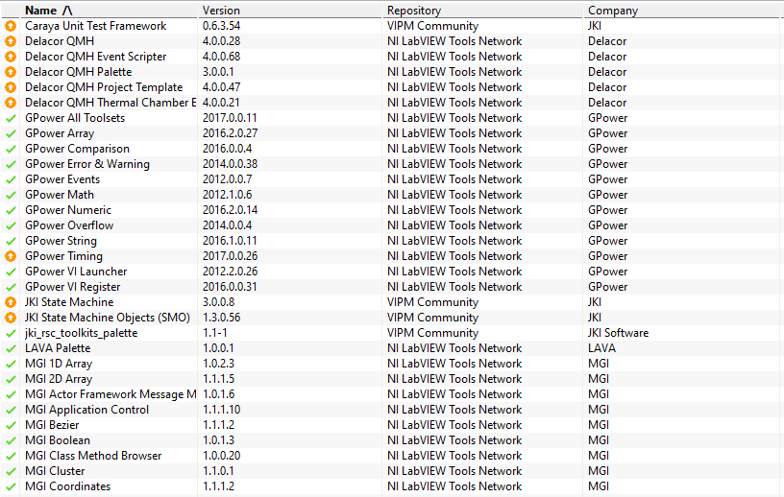

**VIPM Installed Packages Page #2**

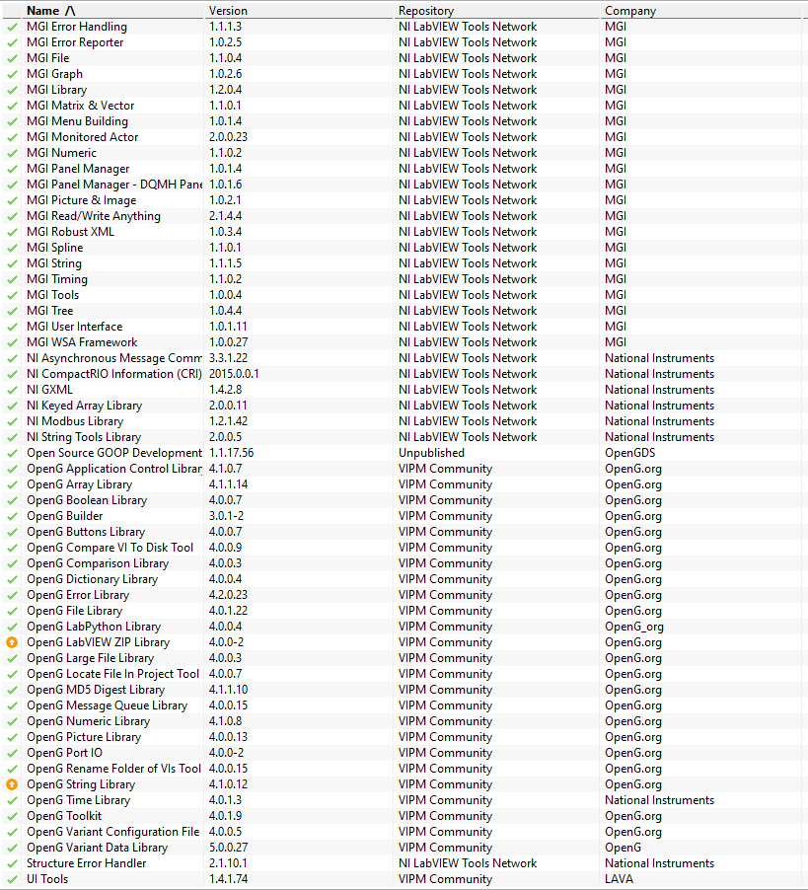

## **MAX Software Summary**

Max Software Summary Page 1

|  |  |
| --- | --- |
| **Name** | **Version** |
| NI-CAN | 15.0.0f0 |
| CompactRIO | 18.1.0 |
| C Series Module Support | 18.1.0 |
| CVI | 15.0.0 |
| Real-Time | 15.0.0 |
| CVI AddOns | LabWindows/CVI Shared AddOns |
| PID Toolkit | 2.1.0 |
| Profiler Toolkit | 1.0.0 |
| Real-Time Trace Viewer - CVI Support | 15.0.0 |
| Signal Processing Toolkit | 7.0.2 |
| SQL Toolkit | 2.3.0 |
| CVI Runtime | 15.0.0.408 |
| NI-DAQmx Device Driver | 19.0.0f1 |
| NI-DAQmx ADE Support | 18.1.0 |
| NI-DAQmx MAX Configuration | 18.1.0 |
| NI Script Editor | 14 |
| NI-DMM |  |
| Configuration Support | 15 |
| Development Support | 15 |
| Runtime | 15 |
| DMM Soft Front Panel | 15.0.0 |
| NI-FGEN |  |
| Configuration Support | 15 |
| Development Support | 15 |
| Runtime | 15 |
| FGEN Soft Front Panel | 15 |
| NI-488.2 Runtime | 19.0.0 |
| NI-488.2 | 15.0.0 |
| NI-IMAQ | 19.0.0 |
| Runtime 19.0.0 | 19.0.0 |
| NI-IMAQ I/O | 19.0.0 |
| Runtime 19.0.0 | 19.0.0 |
| Vision Common Resources | 19.0.0 |
| Image Processing and Machine Vision | 19.0.0.49152 |
| Image Services | 19.0.0.49152 |
| NI-Industrial Communications for EtherCAT | 18.0.0f1 |

Max Software Summary Page 2

|  |  |
| --- | --- |
| NI I/O Trace | 19.0.0f0 |
| IVI Compliance Package | 15 |
| LabVIEW 2015 (64-bit) | 15.0.0 |
| LabVIEW Runtime 2012 SP1 f9 | 12.0.1 |
| LabVIEW Runtime 2012 SP1 f9 (64-bit) | 12.0.1 |
| Measurement & Automation Explorer | 18.0.0f0 |
| Measurement Studio | Visual Studio 2010 Support. |
| DotNET |  |
| Common | 15.0.40.49154 |
| Common (64-bit) | 15.0.40.49154 |
| NI-USI | 17.0.0.6654 |
| NI-DCPower |  |
| Configuration Support | 15 |
| Development Support | 15 |
| Runtime | 15 |
| NI-DCPower Soft Front Panel | 15 |
| NI-HSDIO |  |
| Configuration Support | 15 |
| Development Support | 15 |
| Runtime | 15 |
| NI-HWS | 15.0.0 |
| NI-IMAQdx | 19.0.0 |
| Runtime 19.0.0 | 19.0.0 |
| USB3 Vision Driver | 19.0.0.49152 |
| GigE Vision Driver | 1.9.3.49152 |
| NI PXI Platform Services Configuration | 18.0.0f0 |
| NI PXI Platform Services Runtime | 19.0.0f1 |
| NI R Series Multifunction RIO | 15.0.0 |
| NI-Sync Runtime | 15.0.1f0 |
| NI-Sync | 18.1.0f0 |
| NI-TimeSync | 15.0.0f0 |
| NI-XNET Runtime | 19.0.0f1 |
| FlexRIO | 15.0.0f0 |
| NI-PAL Software | 19.0.0 |
| NI 1588-2008 Network Management 15.0.0 | 15.0.0f0 |
| NI-SCOPE |  |

Max Software Summary Page 3

|  |  |
| --- | --- |
| Configuration Support | 15 |
| Development Support | 15 |
| Runtime | 15 |
| SCOPE Soft Front Panel | 15 |
| NI-Serial Runtime | 19.0.0f0 |
| NI-Serial Configuration | 17.5.0f0 |
| NI SignalExpress | 15 |
| NI-SWITCH | 15 |
| Configuration Support | 15 |
| Development Support | 15 |
| Runtime | 15 |
| Soft Front Panel | 18.1.0 |
| NI System Configuration | 19.0.0f0 |
| NI-TClk | 15 |
| NI-VISA | 19 |
| NiVisaServer.exe | 15.0.0.49152 |
| NIvisaic.exe | 18.0.0.49152 |
| NI-VISA Runtime | 19 |
| Vision Development Module | 19.0.0 |
| Runtime Support 2019 | 19.0.0 |
| LabVIEW | 15.0.1 |
| Advanced Signal Processing Toolkit | 15.0.0 |
| Database Connectivity Toolkit | 15.0.0 |
| DataFinder Toolkit | 15.0.06020 |
| Digital Filter Design Toolkit | 15.0.0 |
| MathScript RT Module | 15.0.0 |
| Real-Time | 15.0.1 |
| Real-Time Trace Viewer - LabVIEW 2015 Support | 15.0.1 |
| Report Generation Toolkit For Microsoft Office | 15.0.0 |
| Statechart Module | 15 |
| Unit Test Framework Toolkit | 15.0.0 |
| VI Analyzer Toolkit | 15.0.0 |
| LabVIEW Runtime 2013 SP1 f6 | 13.0.1 |
| LabVIEW Runtime 2014 SP1 f11 | 14.0.1 |
| LabVIEW Runtime 2015 SP1 | 15.0.1 |
| LabVIEW Runtime 2016 f5 | 16.0.0 |

Max Software Summary Page 3

|  |  |
| --- | --- |
| LabVIEW Runtime 2017 SP1 f3 | 17.0.1 |
| LabVIEW Runtime 2018 SP1 f3 | 18.0.1 |
| LabVIEW Runtime 2019 SP1 f3 | 19.0.1 |
| LabVIEW Runtime 2014 SP1 f11 (64-bit) | 14.0.1 |
| LabVIEW Runtime 2015 f2 (64-bit) | 15.0.0 |